TFY4215 Kjemisk fysikk og kvantemekanikk Spring 2006
Chemical physics Solution to Exercise 1

Ethene.

(With the full responsibility, but with no guarantees, when it comes to misprints and other errors…!)

6. With the Hartree – Fock method and the basis set 3-21G, one obtains an equilibrium geometry for ethene with the bond lengths C-H = 1.074 Å and C-C = 1.315 Å, and the bond angles HCH = 116.2º and HCC = 121.9º. Compared with the experimental values C-H = 1.076 Å, C-C = 1.33 Å, HCH = 116.6º and HCC = 121.7º, this yields a mean error of

This relatively small deviation between theory and experiment is somewhat accidental, I assume. Since I made the exercise text, I have also found other experimental values, for example 1.339 Å, 1.085 Å and 117.8º for the bond lengths C-H and C-C and the bond angle HCH, respectively. With these values, the mean error becomes ca 1.2%. Note that the bond angles HCH and HCC are not independent in such a symmetric molecule: With all six atoms in the same plane and in addition all four H-atoms symmetrically located with respect to the two C-atoms, the bond angle HCH is fixed (as 360º – 2 × HCC) as soon as the bond angle HCC is known, and vice versa. In other words, the geometry of the molecule, which at the outset is determined by 18 coordinates – x, y, and z for each of the 6 atoms – is completely determined by only 3 so-called internal coordinates, two bond lengths and one bond angle. The symmetry fixes the rest of the coordinates. With this wisdom, we should probably remove one of the terms in the sum above and divide by 3 instead of 4. For example, if we remove the last term (i.e. the error in the bond angle HCC), the mean errors become 0.6 and 1.4%, respectively, with the two mentioned sets of experimental values. Alternatively, we could remove the third term (i.e. the error in the bond angle HCH), which will give a mean error of 0.5 and 1.2%, respectively. In other words: Roughly the same mean error, independent of which “method” we use.

7.
a) With the basis set 3-21G (or, to be precise, 3-21G(*), in the case you encounter similar things later in your life), we have, as mentioned in the exercise text, included two s-functions for each H-atom and three s- and six p-functions for each C-atom. All together 4 × 2 + 2 × 9 = 26 basis functions. This means that each molecular orbital (MO) is expressed as a linear combination of these 26 basis functions ,
with coefficients that denote the ”contribution” from basis function number μ to MO number i. ”To solve the quantum mechanical problem” for a given molecule then means finding the set of coefficients such that the total energy of the molecule becomes as low as possible.
Carbon har atom number 5, i.e. 6 electrons, while hydrogen has 1 electron. Hence, ethene has a total of 16 electrons

b) Inspection of c2h4.spartan with Display – Output shows (at least in my computation) that the program used 3 iterations to optimize the geometry:

Point Group = DNH Order = 2 Nsymop = 8
This system has 3 degrees of freedom
Hessian from MMFF94 calculation used.
Max. Max. Neg.
Cycle Energy Grad. Dist. Eigen
1 -77.5981973 0.01855 0.00897
2 -77.6008962 0.00331 0.00021
3 -77.6009879 0.00015 0.00000

M001

E(HF) = -77.6009879 a.u.

c) Optimization of the geometry and computation of the vibrational frequencies took 1.3 CPU-seconds:
Reason for exit: Successful completion
HF Program CPU Time : 000:00:01.3
HF Program Wall Time: 000:00:01.5
In a Hartree – Fock calculation, the CPU time will roughly scale as the number of basis functions raised to the fourth power. Here, we have relatively few basis functions, and in addition a symmetrical molecule, so that the number of degrees of freedom becomes small (3, see point 6 above) and the computation time short. With an increasing number of atoms and lack of symmetry, it soon becomes a significant numerical job.

d) The two C-atoms lie on the z axis, the whole molecule in the xz plane:
Cartesian Coordinates (Angstroms)
Atom X Y Z
--------- ------------- ------------- -------------

1 H H1 0.9115633 0.0000000 -1.2253162
2 C C1 0.0000000 0.0000000 -0.6575621
3 C C2 0.0000000 0.0000000 0.6575621
4 H H2 -0.9115633 0.0000000 -1.2253162
5 H H3 0.9115633 0.0000000 1.2253162
6 H H4 -0.9115633 0.0000000 1.2253162

e) Ethene has 16 electrons. According to the Pauli principle, we can only have one electron in each single particle state. In each MO, we may have one electron with spin “up” and one electron with spin “down”. Hence, we fill 8 MOs with 16 electrons. The ground state corresponds to the situation where we occupy the 8 MOs with the lowest energy, two electrons in each of these. The HOMO orbital is the ”Highest Occupied Molecular Orbital”, i.e., the one among the occupied MOs with the highest energy, hence MO number 8. The LUMO orbital is the ”Lowest Unoccupied Molecular Orbital”, i.e., the one among the unoccupied orbitals with the lowest energy, hence MO number 9. Orbital ”HOMO – n” is therefore MO number 8 – n.

f) The orbital HOMO looks like this:
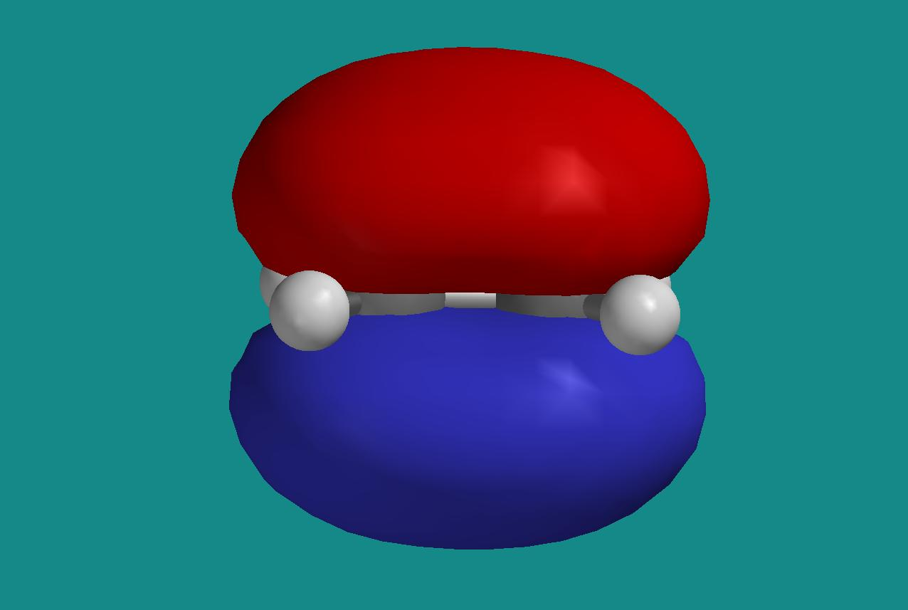
The red half represents a surface with constant negative value of the orbital, the blue half a surface with the corresponding positive value. With the molecule localized in the xz plane, it is clear that we have here p_{y} orbitals on the C-atoms that contribute to the MO. This is consistent with the coefficients for MO number 8 in the output file:
MO: 6 7 8 9 10
Eigenvalues: -0.59082 -0.49887 -0.37970 0.18659 0.29869
(ev): -16.07714 -13.57503 -10.33206 5.07744 8.12775

Ag B3g B3u B2g Ag
1 H1 S 0.11943 -0.17957 0.00000 0.00000 0.01584
2 H1 S 0.11014 -0.15673 0.00000 0.00000 0.96355
3 C1 S 0.00829 0.00000 0.00000 0.00000 0.09064
4 C1 S -0.02161 0.00000 0.00000 0.00000 -0.03106
5 C1 PX 0.00000 -0.26064 0.00000 0.00000 0.00000
6 C1 PY 0.00000 0.00000 0.32177 0.30232 0.00000
7 C1 PZ -0.36461 0.00000 0.00000 0.00000 0.12964
8 C1 S 0.02856 0.00000 0.00000 0.00000 -1.39568
9 C1 PX 0.00000 -0.27725 0.00000 0.00000 0.00000
10 C1 PY 0.00000 0.00000 0.37234 0.76201 0.00000
11 C1 PZ -0.22153 0.00000 0.00000 0.00000 0.63273
12 C2 S 0.00829 0.00000 0.00000 0.00000 0.09064
13 C2 S -0.02161 0.00000 0.00000 0.00000 -0.03106
14 C2 PX 0.00000 0.26064 0.00000 0.00000 0.00000
15 C2 PY 0.00000 0.00000 0.32177 -0.30232 0.00000
16 C2 PZ 0.36461 0.00000 0.00000 0.00000 -0.12964
17 C2 S 0.02856 0.00000 0.00000 0.00000 -1.39568
18 C2 PX 0.00000 0.27725 0.00000 0.00000 0.00000
19 C2 PY 0.00000 0.00000 0.37234 -0.76201 0.00000
20 C2 PZ 0.22153 0.00000 0.00000 0.00000 -0.63273
21 H2 S 0.11943 0.17957 0.00000 0.00000 0.01584
22 H2 S 0.11014 0.15673 0.00000 0.00000 0.96355
23 H3 S 0.11943 0.17957 0.00000 0.00000 0.01584
24 H3 S 0.11014 0.15673 0.00000 0.00000 0.96355
25 H4 S 0.11943 -0.17957 0.00000 0.00000 0.01584
26 H4 S 0.11014 -0.15673 0.00000 0.00000 0.96355

Only for μ = 6, 10, 15 and 19, MO nr 8 has non-zero coefficients. These four are p_{y} orbitals on the two carbon atoms C1 and C2. We further note that the two C-atoms contribute with the same sign for corresponding atomic orbitals (6 and 15, 10 and 19, respectively). This results in a so-called “bonding” MO.

g) LUMO is MO nr 9, it looks like this:
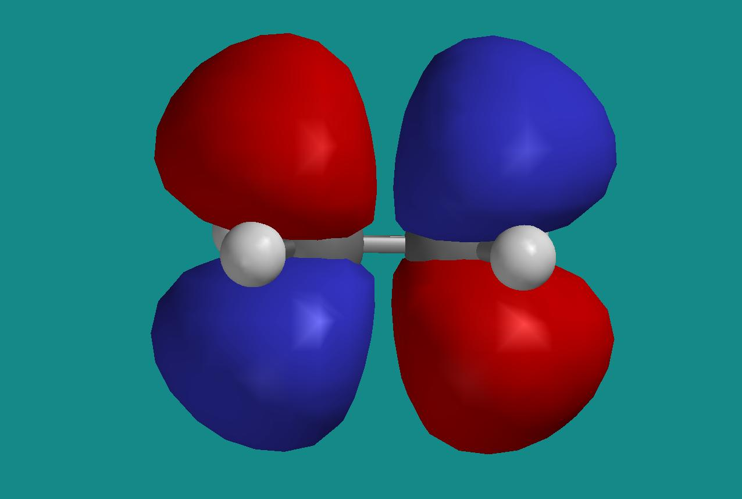

From the output file, we see that LUMO is made up of the same four p_{y} orbitals as HOMO, but this time with opposite sign for corresponding atomic orbitals on the two C-atoms. This results in a so-called “anti-bonding” MO. LUMO has “nodal planes” (i.e. planes where LUMO is zero) both in the xz and in the xy plane, HOMO has a nodal plane only in the xz plane. This is consistent with what you have learnt earlier in the course, namely that LUMO then will have a higher energy than HOMO.

HOMO – 7 is MO number 1, i.e., the one with the lowest energy. It looks like this:
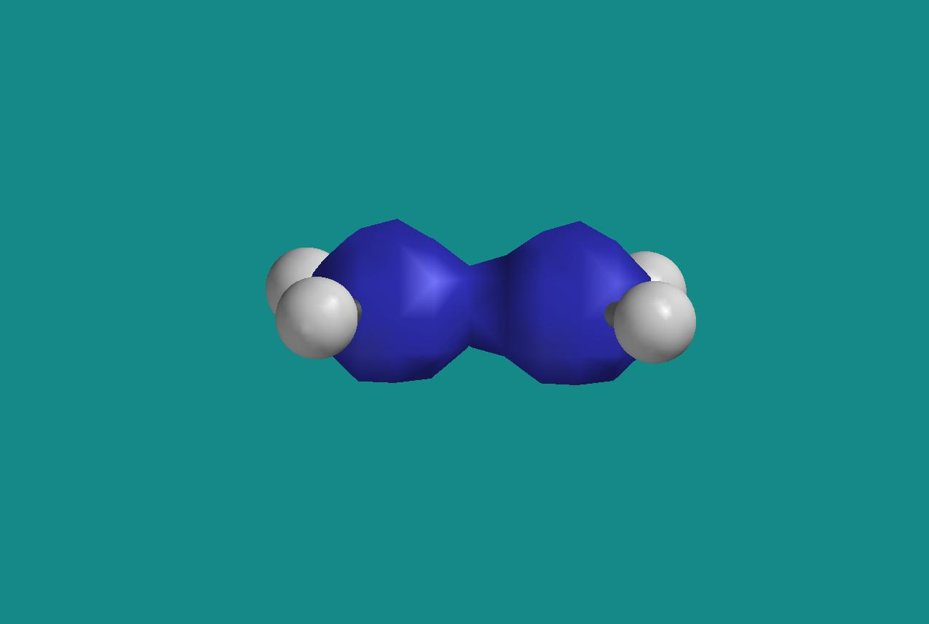
It looks as if this MO is built from s-orbitals on carbon, and this is consistent with the fact that the coefficients and are the dominating ones in MO number 1:
MO: 1 2 3 4 5
Eigenvalues: -11.16625 -11.16605 -1.03819 -0.78870 -0.64657
(ev): -303.84929 -303.84375 -28.25049 -21.46163 -17.59397

Ag B1u Ag B1u B2u
1 H1 S -0.00179 0.00028 0.07766 -0.13828 0.14663
2 H1 S 0.00968 -0.00805 0.00398 -0.06692 0.10789
3 C1 S 0.69758 -0.69791 -0.16680 0.12774 0.00000
4 C1 S 0.06538 -0.07106 0.18317 -0.13113 0.00000
5 C1 PX 0.00000 0.00000 0.00000 0.00000 0.28001
6 C1 PY 0.00000 0.00000 0.00000 0.00000 0.00000
7 C1 PZ -0.00169 -0.00207 0.11052 0.14357 0.00000
8 C1 S -0.03146 0.06770 0.36822 -0.41834 0.00000
9 C1 PX 0.00000 0.00000 0.00000 0.00000 0.19335
10 C1 PY 0.00000 0.00000 0.00000 0.00000 0.00000
11 C1 PZ 0.00440 0.01563 0.01587 0.06341 0.00000
12 C2 S 0.69758 0.69791 -0.16680 -0.12774 0.00000
13 C2 S 0.06538 0.07106 0.18317 0.13113 0.00000
14 C2 PX 0.00000 0.00000 0.00000 0.00000 0.28001
15 C2 PY 0.00000 0.00000 0.00000 0.00000 0.00000
16 C2 PZ 0.00169 -0.00207 -0.11052 0.14357 0.00000
17 C2 S -0.03146 -0.06770 0.36822 0.41834 0.00000
18 C2 PX 0.00000 0.00000 0.00000 0.00000 0.19335
19 C2 PY 0.00000 0.00000 0.00000 0.00000 0.00000
20 C2 PZ -0.00440 0.01563 -0.01587 0.06341 0.00000
21 H2 S -0.00179 0.00028 0.07766 -0.13828 -0.14663
22 H2 S 0.00968 -0.00805 0.00398 -0.06692 -0.10789
23 H3 S -0.00179 -0.00028 0.07766 0.13828 0.14663
24 H3 S 0.00968 0.00805 0.00398 0.06692 0.10789
25 H4 S -0.00179 -0.00028 0.07766 0.13828 -0.14663
26 H4 S 0.00968 0.00805 0.00398 0.06692 -0.10789

HOMO – 6, i.e. MO number 2, is essentially the antisymmetric version of MO number 1:
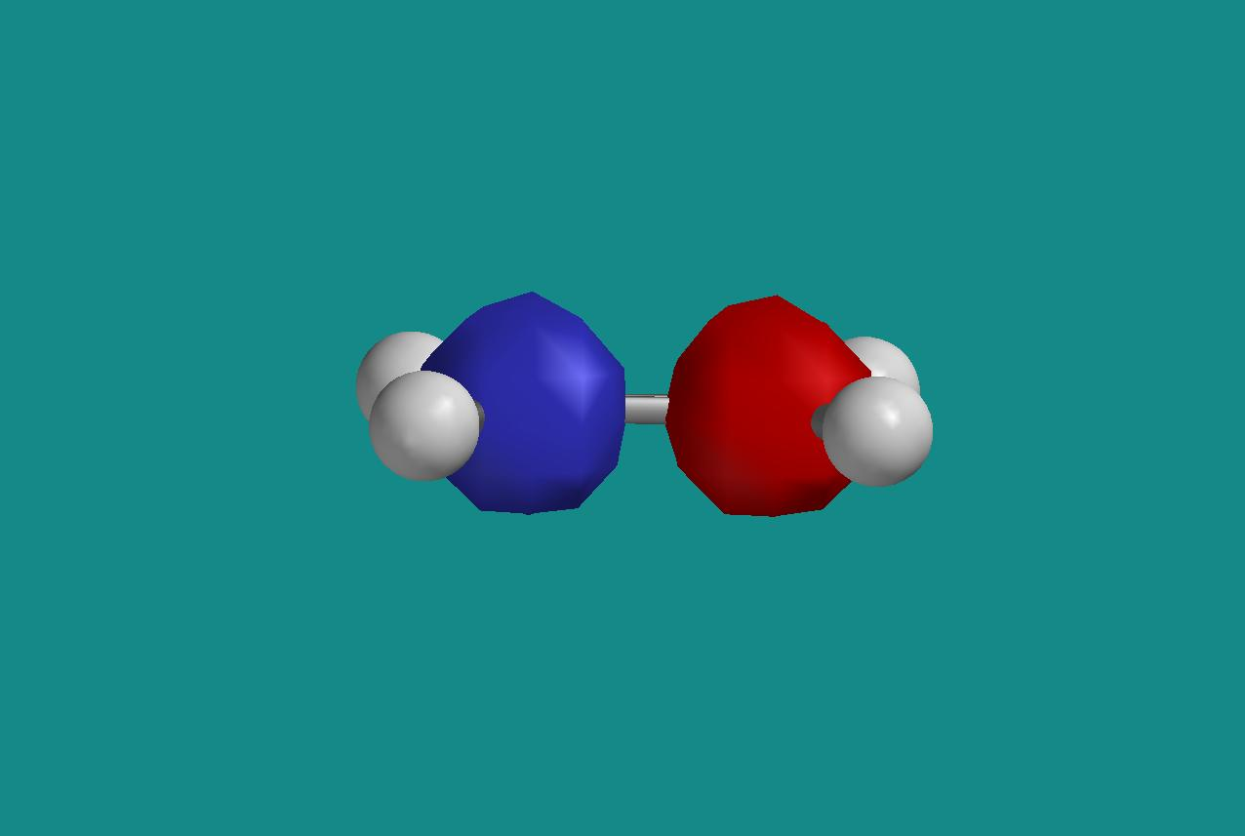

We see from the coefficients in the output file that this orbital is also made from s-functions on carbon, with a positive sign on one of them and a negative sign on the other. In MO number 2, the xy plane is a nodal plane, in MO number 1, we have no nodal planes. Again, an example of a bonding and an anti-bonding MO, where the latter has the highest energy of the two.

HOMO – 5, i.e., MO number 3 looks like this:
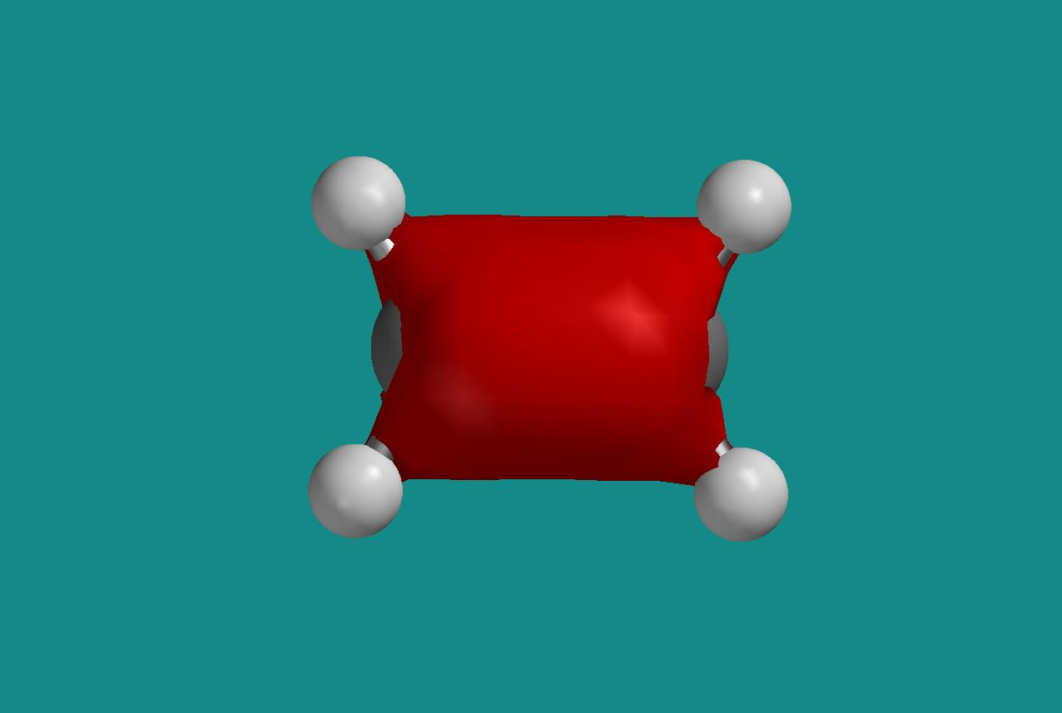
We see that this is an orbital with even parity (so-called ”gerade”, as opposed to ”ungerade” for an orbital with odd parity), but apart from that, it may be difficult to determine visually which atomic orbitals that contribute. Inspection of the coefficients in the output file shows that it is primarily s-orbitals on carbon (and partly on hydrogen) and p_{z}-orbitals on carbon that are the “building blocks” in this molecular orbital. Hence, this MO is the one coming closest to the so-called σ-orbital in exercise 10.

h) Even parity (“gerade”) for an MO means that it has the same sign in position r and –r, while odd parity (”ungerade”) for an MO means that is has the opposite sign in r and –r. From the figures in g) above, we can see that LUMO, HOMO – 7, and HOMO – 5 are all of the type gerade, whereas HOMO and HOMO – 6 are of the type ungerade. This is consistent with the symmetry notation given in the output file, for example B2g, B3u and so on, right above the column with the coefficients .

i) The surface with constant electron density and a color code for the electrostatic potential looks like this:
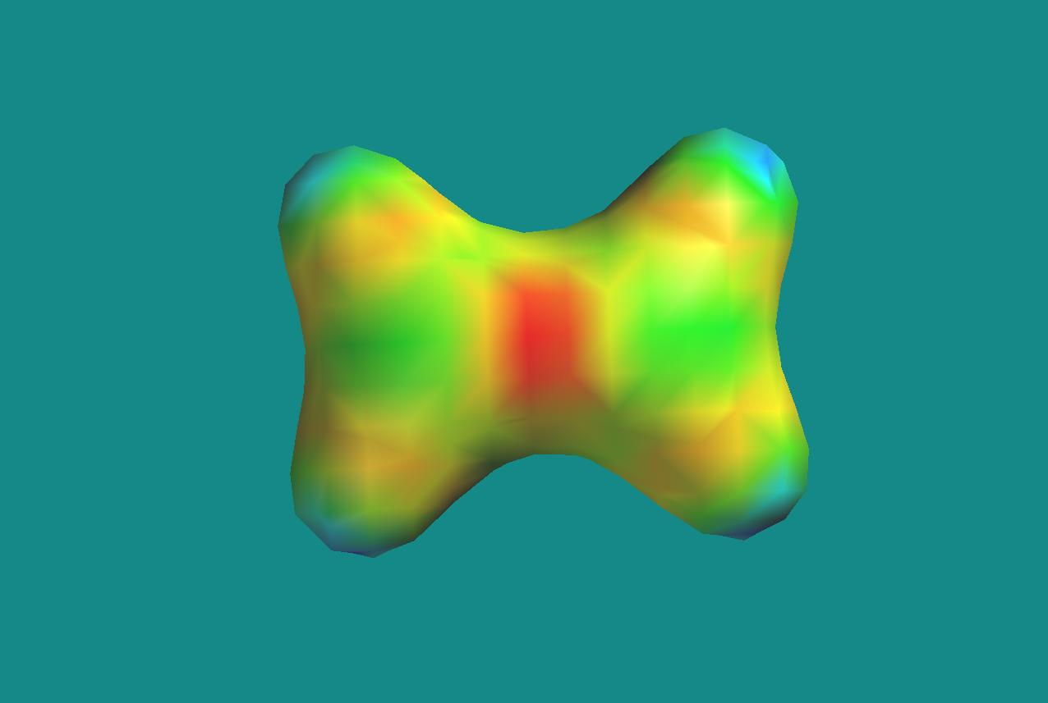

Not surprisingly, we find the region with the lowest value of the potential (red) centrally located in the double bond between the two carbon atoms. This is a region that is “rich in electrons”, and hence will be attracted by electrophile (i.e. “poor in electrons”) regions in possible reaction partners.

8.
a) We will transform the wave number region from 4000 to 500 cm⁻¹ into corresponding regions for the wave length, the frequency, and the energy of the absorbed light. We have the relations , and between wave number k, wave length λ, light velocity c, frequency f, energy E and Planck’s constant h. Hence:
(4000,500) cm⁻¹ for k corresponds to (15.7,126) μm for λ, (2387,19100) GHz for f, and (10,79) meV for E.
In comparison, we find visible light in the wave length region (0.40,0.76) μm. In other words, the vibrational frequencies in the molecule correspond to wave lengths in the infrared region.

b) In our calculation, we find the strongest vibrational band at 1116 cm⁻¹. This value must be scaled with a factor 0.85 to give the experimental value of 949 cm⁻¹. The factor of 0.85 is even smaller than what one usually must use for Hartree – Fock evaluated frequencies (around 0.90), but there is no doubt we have localized the “correct” vibrational mode.

c) Illustration of the vibrational movement for the frequency 1116 cm⁻¹:
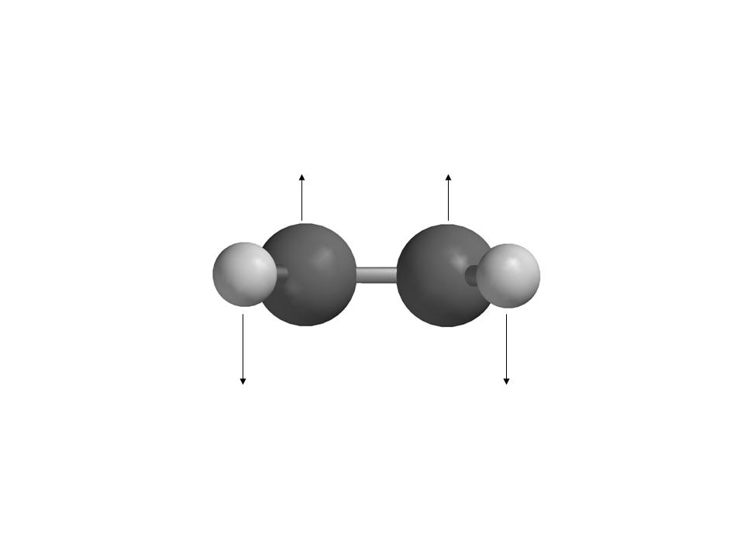
If we consider each H-atom as a positive point charge and each C-atom as a negative point charge, it should be clear that this vibrational movement represents an oscillating electric dipole. Thus, this vibration can be excited by the oscillating electric field in the incoming electromagnetic wave.
The band at 1522 cm⁻¹ is an example of an IR-inactive mode. The corresponding vibrational movement takes place in the plane of the molecule (the xz plane) and may be illustrated like this:
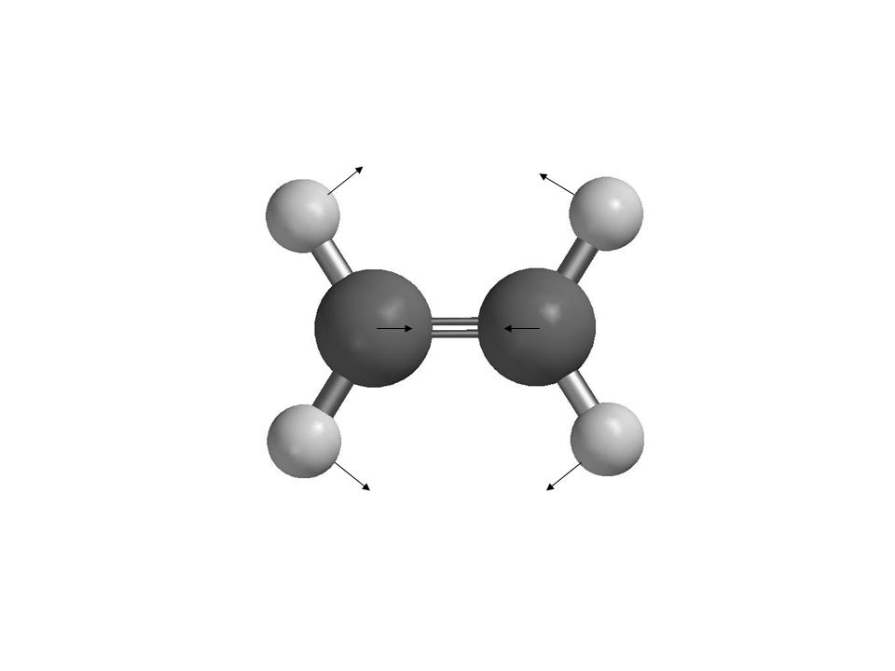
We see that this vibration does not correspond to an oscillating electric dipole – the electric dipole moment of the molecule is zero at all times throughout the vibrational movement. Hence, this mode will not be excited by the oscillating electric field in the incoming electromagnetic wave.

9.
I obtained the following Hartree – Fock energies for the molecules involved:

Pentane: -195.2515601 a.u.
Heptane: -272.8897730 a.u.
Ethene: -77.6009879 a.u.
This yields a reaction energy for ”pentane + ethene → heptane” of –0.037225 a.u., or –23.4 kcal/mol. This is actually surprisingly close to the experimentally measured polymerization energy of –25 kcal/mol.

