TFY4215 Kjemisk fysikk og kvantemekanikk Spring 2006
Chemical physics Solution to Exercise 3

Basepairs in DNA.

3.
a) For A-DNA, the period is ca 28 Å, and there are 11 P-atoms per period. For B-DNA, the period is ca 34 Å, and there are 10 P-atoms per period. (This clarifies my comment in the exercise text.)

b) I have measured these distances in B-DNA:

Between cytosine (C) and guanine (G):
From H in C to O in G: 1.876 Å
From N in C to H in G: 1.850 Å
From O in C to H in G: 1.881 Å

Between thymine (T) and adenine (A):
From O in T to H in A: 1.984 Å
From H in T to N in A: 1.882 Å

I have measured these distances in A-DNA:

Between cytosine (C) and guanine (G):
From H in C to O in G: 1.837 Å
From N in C to H in G: 1.849 Å
From O in C to H in G: 1.829 Å

Between thymine (T) and adenine (A):
From O in T to H in A: 1.863 Å
From H in T to N in A: 1.881 Å

Typical hydrogen bond lengths are slightly shorter than 2 Å. In comparison, ordinary chemical bonds between O and H and between N and H are ca 1 Å.

During the exercises, I was made aware of the possibility to choose “Hydrogen bonds” in the Model menu. This inserts dashed lines where such hydrogen bonds exist. Combined with “Ball and Wire”, it then becomes much easier to see the hydrogen bonds, and thereby localize G-C and A-T basepairs. Here is a G-C basepair in B-DNA:
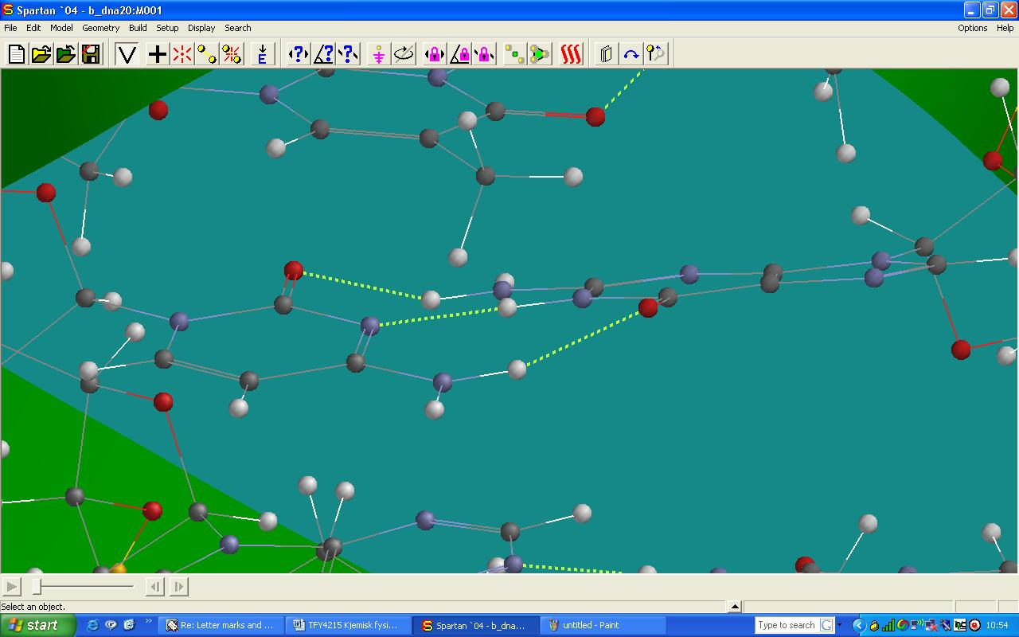

The helical ”outer walls” consist of 2-deoxyribose and phosphate. In the figure below we clearly see two phosphate groups and two carbohydrate groups (fivemembered rings):

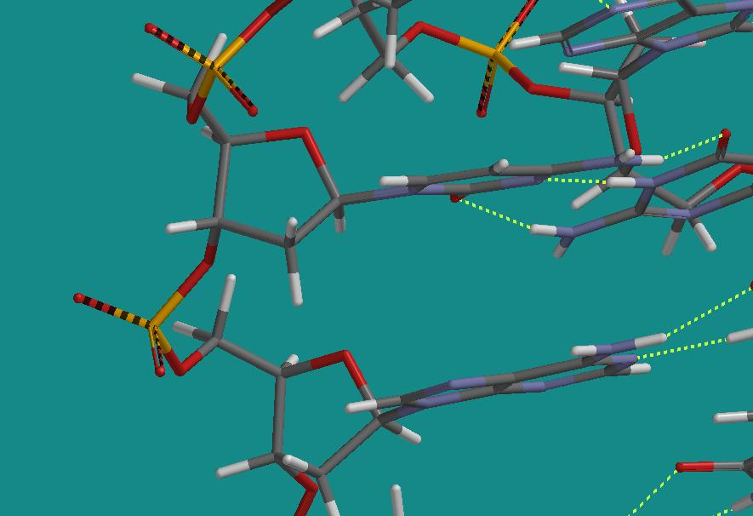

It is not so easy to measure the diameter of the DNA double helix exactly because it is difficult to locate two atoms situated diametrically with respect to each other. In the figure below, B-DNA is oriented with the double helix coming out of the plane. The two small orange balls are Cl-atoms in a Cl₂ molecule where the bond length is set to 24 Å. This seems to be about the size of the diameter of B-DNA.

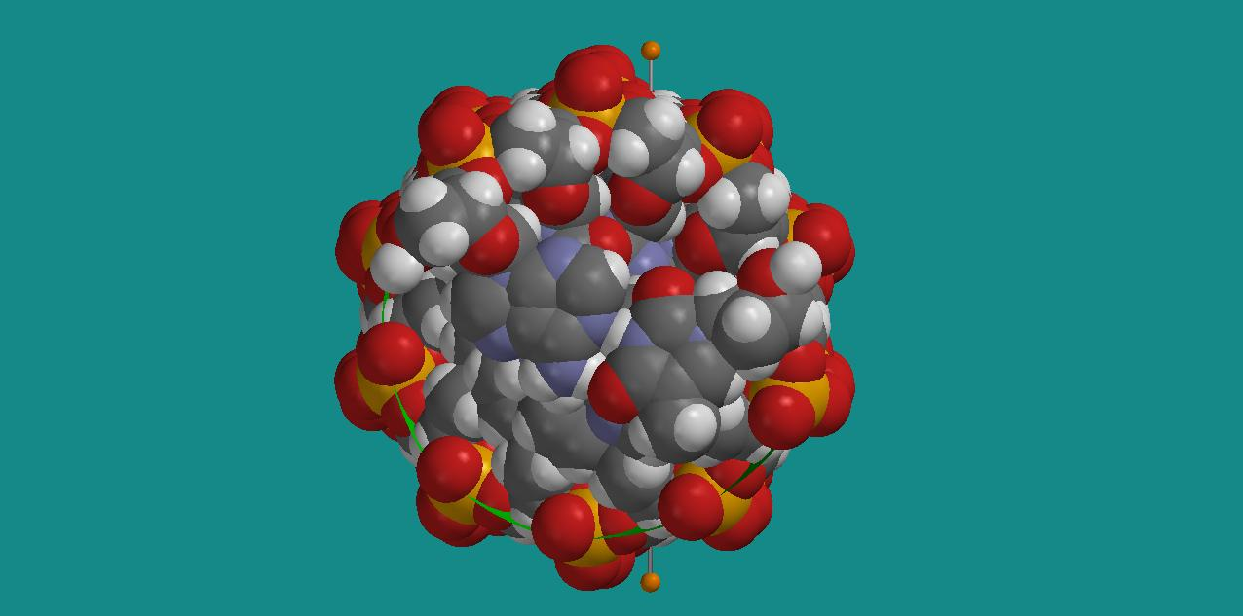

We may do the same with A-DNA:

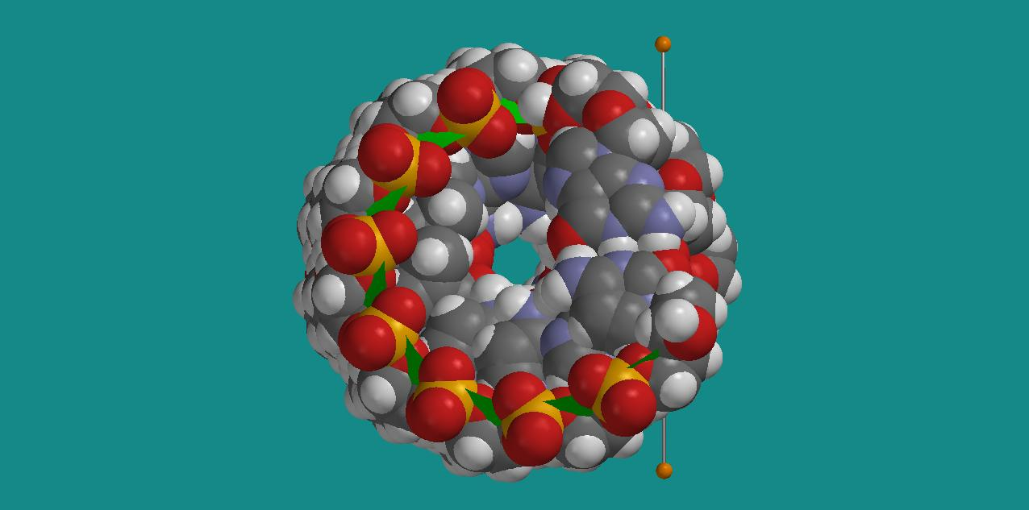

The Cl₂ measuring stick here has a length of 23 Å.
These two figures should also give you an impression of the differences between A-DNA and B-DNA. In B-DNA, which is the type we typically have in our aqueous cells, the phosphate groups are oriented more outwards, so that O-atoms in the phosphate groups define the diameter of the double helix. In A-DNA, there are H-atoms of 2-deoxyribose that point outwards and define its diameter.

With the two types of DNA oriented with the double helix in the plane, we can clearly identify two ”grooves” in B-DNA, whereas in A-DNA, there is more like an ”opening” into the centre of the molecule (in addition to a wide and shallow valley). In the figures below, we have again inserted Cl₂ measuring sticks, showing that the two grooves in B-DNA have widths of 12 and 4 Å, respectively, while the opening in A-DNA has a width of about 3 Å.

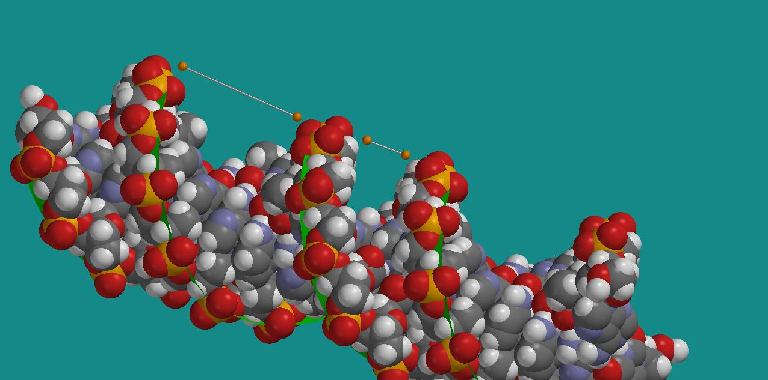
B-DNA: Two grooves of width 12 and 4 Å

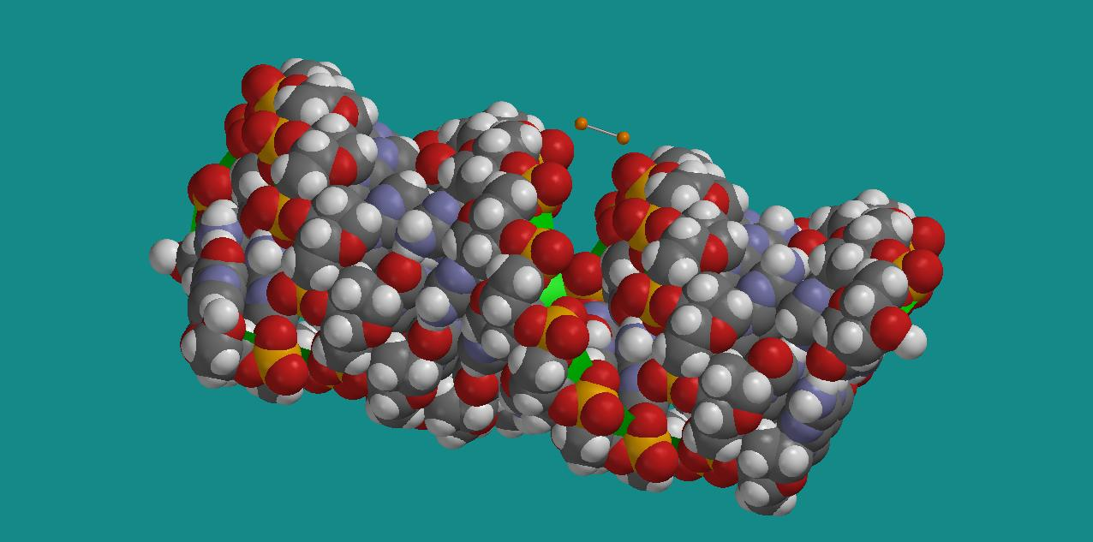
A-DNA: Opening of width ca 3 Å

c) Relevant atomic masses are:
m(H)=1, m(C)=12, m(O)=16, m(N)=14 and m(P)=31
Hence:
m(PO₄)=95, m(2-deoxyribose)=134, m(A)=135, m(T)=126, m(C)=111 and m(G)=151
Connection of phosphate groups and amino bases to the carbohydrate takes place where the carbohydrate has its OH groups, and in a way such that the O-atom in these 3 OH groups ”vanish”. Therefore, we should subtract the mass of 3 O-atoms for the carbohydrate and use m(2-deoxyribose)=98. Then, one A-T basepair has mass 261 and one G-C basepair has mass 262. On average, we may therefore use a mass of 65 per amino base. Each “building block” consisting of phosphate + carbohydrate + amino base will then have an average mass of 258. We have two helices, so on the length occupied by one P-atom (per helix) along the DNA molecule, we have a mass of 516.
The mass unit here is the mass of a nucleon, ca 1.67⋅10⁻²⁷ kg. Hence, the mass per length per P-atom is then 516⋅1.67⋅10⁻²⁷ kg = 8.6⋅10⁻¹⁷ kg.
In A-DNA, we have 11 P-atoms on a length 28 Å, i.e., 1 P-atom per length (28/11)⋅10⁻⁸ cm. Hence, 3.9⋅10⁷ P-atoms (per spiral) on a length 1 cm, so that an A-DNA molecule of length 1 cm will have a mass 3.4⋅10⁻¹⁷ kg.
In B-DNA, we have 10 P-atoms on a length 34 Å, i.e., 1 P-atom per length (34/10)⋅10⁻⁸ cm. Hence, 2.9⋅10⁷ P-atoms (per spiral) on a length 1 cm, so that a B-DNA molecule of length 1 cm will have a mass 2.5⋅10⁻¹⁷ kg.

4.
a) Calculations with the Hartree – Fock method and the basis set 3-21G yields:

E(G) = - 536.365253 au
E(C) = - 390.416205 au
E(G-C basepair) = -926.844981 au
Calculated binding energy is therefore:

E_{b} = E(G-C) - E(G) - E(C)
= - 926.844981 + 536.365253 + 390.416205
= - 0.063523 au
= - 39.9 kcal/mol

As mentioned in the exercise text: This is substantially more than what we actually have in nature. Rather than a binding energy per hydrogen bond of 10 – 15 kcal/mol (as found here), we probably have something lik 2 – 5 kcal/mol per hydrogen bond.
Anyway, the calculations still show that we are dealing with a kind of bonds that are much weaker than ordinary covalent bonds and ionic bonds. On
http://www.cem.msu.edu/~reusch/VirtualText/react2.htm
I found a table which provides ”Standard Bond Energies”, i.e., typical bond energies for bonds between different kind of atoms. A typical H-H binding energy is slightly above 100 kcal/mol, and that is also the case for the bond between H and Cl.

b) Calculated distances between O and N in the G – C basepair:

O(G) – N(C) = 2.77 Å (Experiment: 2.91 Å)
N(G) – N(C) = 2.90 Å (Experiment: 2.95 Å)
N(G) – O(C) = 2.87 Å (Experiment: 2.86 Å)

5.
In the figure below, we have a G – C basepair at the bottom, with G to the right and C to the left, and an A – T basepair on top, with A to the right and T to the left:

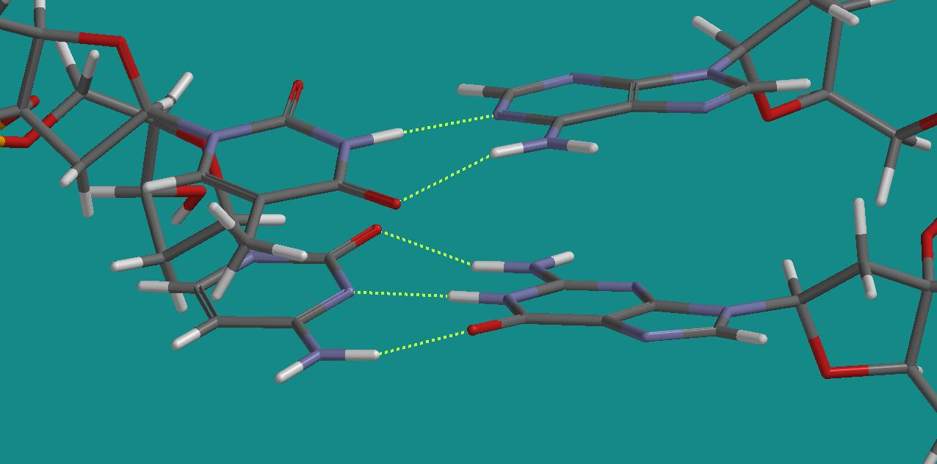

Interchanging C and T will result in a G – T basepair at the bottom and an A – C basepair on top. We see that if we simply translate T downwards, an O on T will “meet” an O on G, and an H on T will meet an H on G, and this does not result in stabilizing hydrogen bonds. In the same manner, by translating C upwards: An H on C will meet an H on A, and an N on C will meet an N on A. Only the O on C and an H on A could possibly result in a hydrogen bond.
These observations are consistent with the fact that we only find basepairs of the type G – C and A – T in natural DNA. However, let us not be too conclusive at this stage: I am sure you can make other combinations that appear to become stable and nice, but of a type that you do not find in nature. So, there are probably other decisive factors as well that we have not discussed in this exercise.

