TFY4215 Kjemisk fysikk og kvantemekanikk Spring 2008
Chemical physics, exercise 2
To be delivered by: Monday 05.05.

S_{N}2 reaction.

Introduction
Many chemical reactions can be classified as so-called nuclephile substitution reactions. A nucleophile is rich in electrons, and likes to form chemical bonds with whatever is poor in electrons (which is therefore electrophile). A nuclephile often has a negative charge, but may also be neutral. Substitution means that something is replaced by something else during the reaction. The notation S_{N}2 simply means Substitution, Nucleophile, and bi-molecular (i.e., 2 molecules take part in the reaction). One of the molecules is a nucleophile, while the other is typically (well, perhaps even always – I’m not really a chemist…!) a so-called alkyl halide, with the general formula R₁R₂R₃CX. Here, C is an sp3-hybridized carbon atom, bound to a halogen atom (”halide”) X (i.e. F, Cl, Br or I), while R₁, R₂ and R₃ may be different organic ”groups”, for example methyl (CH₃), hydroxy (OH) etc. etc., or simply a hydrogen atom (H).
As mentioned above, the nucleophile may be negatively charged, or electrically neutral. If it is electrically neutral, it must have “available” electrons in the outer shell that can contribute in the process of making a new bond to the mentioned sp3-hybridized C-atom in the alkyl halide. The S_{N}2 reaction proceeds by the nucleophile “attacking” the alkyl halide on the opposite side compared to where the halide X is located. Next, a new bond is formed between the nucleophile and the “central” C-atom, while the halide on the opposite side is forced to leave the C-atom. The halide takes along both the electrons that originally made up the C-X bond, so the product of the reaction becomes X- and NuCR₁R₂R₃, where Nu denotes the nucleophile. If the nucleophile originally was an anion, the product NuCR₁R₂R₃ becomes electrically neutral. If the nucleophile originally was electrically neutral, the product NuCR₁R₂R₃ becomes a cation (with charge +1; well, actually +e, of course).
Let us concretize with an example, choosing the reaction that will be modelled in this exercise: We choose a bromide, Br-, as the nucleophile and the alkyl halide with X=Cl and R₁=R₂=R₃=H, in other words ClCH₃, methyl chloride (alternatively, chloro methane). Thus, our S_{N}2 reaction is

Br- + ClCH₃ → BrCH₃ + Cl-

We will study this reaction by means of Hartree-Fock calculations. The kinetics of the reaction will be discussed in terms of a calculated activation energy (i.e. energy barrier) for the reaction. Next, we will consider this as a chemical equilibrium between two stable “complexes”, one with bromide coordinated (i.e. weakly bound) to methyl chloride, and the other with chloride coordinated to methyl bromide.
A rather important point is that the so-called stereochemistry of the central carbon atom becomes inverted in an S_{N}2 reaction, provided that this carbon atom is a co-called stereogenic center. (Which simply means that is has four different groups attached to it.) Briefly, this implies that the molecule will have different optical properties before and after the S_{N}2 reaction. More about this in section 4 below; hopefully you will get there in time!
If you do not get through everything: Take a look at the solution when it comes. Section 6 is a small exercise that you can do later, without using SPARTAN.

Exercises

1. Start SPARTAN by choosing  under Programs.

2. The reactants ClCH₃ and Br-:
Choose File – New (Ctrl+N). Under Organic in the builder menu on the right side, you choose a 4-coordinated (sp3-hybridized) carbon, C. (Left-) Click on the screen. Next, choose chlorine, Cl, and bind this to the C-atom by clicking one of the four open valences. Go back to View mode and save the methyl chloride molecule ClCH₃: Choose File – Save As, make a new directory, call it SN2, and save the molecule with filename clch3 and the (default) filetype Spartan. Set up a Hartree-Fock/3-21G geometry optimization. (You don’t have to change anything under Setup – Calculations, i.e., do not choose Compute IR or Print Orbitals.) Make two iso-surfaces (Setup – Surfaces) for the electron density (density), both with the “isovalue” equal to 0.001. Include the electrostatic potential as a color code (Property – Potential) on one of them. Run the job (Setup – Submit). Close the molecule when it is done. (File – Close).
Choose File – New once more and pick bromine, Br. When you click on the screen, you will get your Br-atom with an open valence. Delete the open valence by choosing and clicking the yellow stick. Go back to View mode and save the bromine atom with filename br. Set up a Hartree-Fock/3-21G energy calculation (Single Point Energy, not much of a geometry to be optimized here, with only one atom!) for the anion Br-. Run the job. Close the molecule when the job is done.

Questions:
a) Open the molecule ClCH₃. Look at the surface with constant electron density (Display – Surfaces). Does this picture suggest where a nucleophile reaction partner primarily will “attack”?
b) Next, look at the surface that in addition displays the electrostatic potential. Can you tell now from which side a nucleophile will react?
c) How large is the calculated electric dipole moment of ClCH₃? (Display – Properties; 1 debye = 3.336×10⁻³⁰ Cm) In comparison, the experimental value is 1.870 debye. In other words, the present calculation overestimates the polarity of this molecule.
d) Find the total energy of the two reactants ClCH₃ and Br-, both in atomic units (that is reported with Display – Properties or Display – Output) and in the unit kcal/mol.

3. The reaction ClCH₃ + Br- → Cl- + CH₃Br:
Choose File – New. Under Inorganic you choose carbon, C, but this time 5-coordinated: Click on the screen. With the left mouse button held down, you may rotate the carbon atom and convince yourself that the five open valences form a so-called trigonal bipyramidal structure, with one bond “up”, one “down”, and the remaining three in one plane, with angles of 120 degrees between them. Attach one-coordinated ( ) Cl and Br to the bonds that are up and down. Go back to View mode and save the molecule with filename sn2. Measure the C-Br bond length and change it to 4.0 Å in the window in the lower right corner: This is an appropriate starting value for modelling the reaction. We will now “lock” this bond length: Choose Geometry – Constrain Distance and click on the bond between C and Br. Next, click on the open padlock in the lower right corner, thereby making it locked. Go back to View mode. We will now define a series of computations where the bond length between C and Br is changed stepwise from 4.0 to 1.9 Å, in steps of -0.1 Å, in other words, with C-Br constrained to 4.0, 3.9, 3.8, … , 2.0 and 1.9 Å, altogether 22 computations. Click on the purple “tag” in the middle of the C-Br bond so that it becomes “picked”. The color will change from purple to brown. Choose Display – Properties. The window called “Constraint Properties” will come up. Check the box Dynamic, change the value to 1.90 Å in the “to”-field, and the value to 22 in the “Steps”-field. Press Enter in both these two fields after you have typed in the correct values, otherwise, the new values will not be stored. Be careful at this stage. Close the window “Constraint Properties”. When you now go back to View mode, the tag on the C-Br bond should be light blue, indicating that a dynamic constraint has been assigned to it, i.e., a series of computations. Now, choose Setup – Calculations, change to “Energy Profile” in the Calculate field and to “Anion” in the Total Charge field, and start the computations with Submit. (Do not compute IR or Orbitals.) When you have started the job, its progression can be inspected with Options – Monitor. You should see two or three jobs running at the same time. The uppermost job is the “master job” for the whole series of 22 geometry optimizations. The output of the master job ends up in the file sn2.spartan and is simply a short summary, i.e., the value of the dynamic constraint with the corresponding calculated energy (in kcal/mol). When the job is complete (after 3-4 minutes), you may inspect this summary with Display – Output. It should look like this:

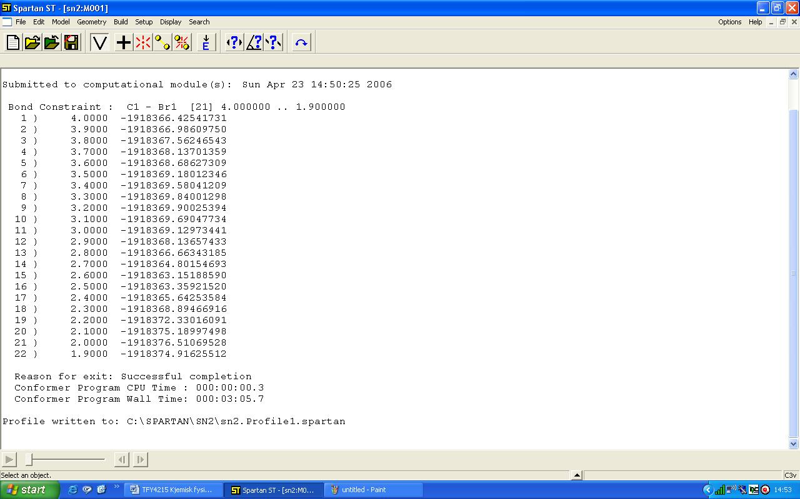

Here, you notice that a new file, sn2.Profile1.spartan, has been created. This file contains the results of all the 22 geometry optimizations, i.e., geometries and corresponding energies, and also the basis for analyzing the results in terms of graphs. Choose File – Close and open the file sn2.Profile1.spartan. “Play” the reaction with the “molecule player” in the lower left corner.
Open the built-in spreadsheet with Display – Spreadsheet. Here, you may enter values for various properties of all the 22 molecules in the reaction series. This is typically done in one of the following two ways: 1) With “Add” at the bottom of the spreadsheet, or 2) By selecting something (for example a constraint, a bond length, etc.) and “posting” it with the button. In this case, we need to enter these properties in the spreadsheet: The C-Br bond length, the total energy E, the calculated atomic charge belonging to Br, and the calculated atomic charge belonging to Cl. A bond length may be posted after you have measured it, while atomic charges are posted via Display – Properties after first selecting (i.e. clicking) a given atom. The energy E is available via Add in the spreadsheet. (kcal/mol is an OK unit for E) Plot E, Q(Br) and Q(Cl) as functions of the C-Br bond length. This is done by using Display – Plots three times, always with “Length” along the x axis, and E, Electrostatic(Br1), and Electrostatic(Cl1), respectively, along the y axis. (You may change the color of things by first selecting them and then using Options – Colors.) The modelled reaction proceeds from right to left, from high towards lower values of the C-Br distance.

Questions:
a) Discuss briefly how the calculated atomic charges on the two halogens change during the reaction. Do the calculated charges approach reasonable values when an atom moves far away from the remaining molecule (ClCH₃, alternatively BrCH₃)?
b) At what C-Br distance do we have a stable “complex”, with the bromide anion “coordinated” to the carbon atom in ClCH₃ (without having made an ordinary chemical bond)? What is the C-Cl bond length in this complex? How strongly is the bromide ion bound to ClCH₃ in this complex? (I.e.: Determine the complexation energy, given by the difference between the energy of the complex and the total energy of the two separate reactants, which you found in 2d above.)
c) The reaction proceeds via a transition state (TS), i.e., a local energy maximum, where the original bond between C and Cl is about to be broken, while a new bond is about to be formed between C and Br. At what C-Br distance do we have the TS? Determine the calculated activation energy E_{a} for the reaction, given by the difference between the energy in the TS and the energy of the complex discussed in b above. At room temperature, the average thermal energy k_{B}T is about 0.6 kcal/mol. The rate of the reaction will depend upon these energies via the Boltzmann factor exp(-E_{a}/k_{B}T). Does this mean that the present reaction essentially will not proceed at room temperature? Discuss!
d) Having passed the TS, the bond between C and Br is completed, and the system reaches a new energy minimum, with the chloride ion Cl- coordinated to the carbon atom in BrCH₃, i.e., a complex similar to the one discussed in b above. What is the C-Br bond length in this complex? What is the corresponding C-Cl distance? Compare the C-Cl bond length in the first complex with the C-Br bond length in this complex. Is the difference as expected?
e) Suppose we mix methyl chloride molecules with an equal number of bromide ions. After a while, the system will reach chemical equilibrium, with a certain concentration of methyl chloride molecules complexed with bromide (the first minimum), and with a certain concentration of methyl bromide molecules complexed with chloride (the second minimum). Determine, using the calculated energy difference between these two complexes, the concentration ratio of the two complexes, at room temperature.

4. S_{N}2 reactions and stereochemistry:
In methyl chloride (and methyl bromide), the carbon atom only has two different “groups” attached to it, namely hydrogen (three of them) and chlorine (or bromine). Then, it doesn’t matter where we put the “unique” atom (here: chlorine or bromine); we obtain exactly the same molecule anyway. You may convince yourself that this is also the case with three different groups bound to the carbon atom, for example by replacing one of the hydrogens with fluorine (F). Even if you interchange the positions of the atoms bound to the carbon, you can always rotate the molecule, making it look exactly as before you did the interchanges.
With four different groups bound to the central carbon atom, this is no longer the case! Convince yourself that this is true by building two versions of 3-chloro-1-butene. You may start with methyl chloride and attach one methyl group, CH₃, and one ethenyl group, HC=CH₂, to two of the open valences. On the other version of the molecule, you interchange the positions of the methyl and the ethenyl groups. With both molecules on the screen simultaneously, convince yourself that they are mirror images of each other, and that it is not possible to rotate one of them until it overlaps with the other. We say that the two molecules are stereoisomers. A gas with only one version of the molecule will for instance have different optical properties than the other: If plane polarized light passes through such a gas, the polarization direction will rotate in one or the other direction, depending on which stereoisomer is present. An equal mixture of the two isomers will not rotate the polarization direction, since the probability of a clockwise rotation is equal to the probability of a counterclockwise rotation. Such properties are easily measured in optical experiments. (We will not go into an explanation of why the polarization is rotated in the first place.)

Question:
Show that an S_{N}2 reaction will change the stereochemistry at the central carbon atom provided it is a stereogenic, or chiral, center (i.e.: it has four different groups attached to it). Hint: Start with the first minimum energy structure (at C-Br=3.20Å) and attach a methyl group and an ethenyl group to two of the open valences. Next, start with the second minimum energy structure (at C-Br=2.0Å) and attach a methyl group and an ethenyl group to the same two open valences. Remove the coordinated bromide ion (and also the emerging “fifth” open valence) from the first minimum energy structure. Remove the coordinated chloride ion from the second minimum energy structure. With both molecules on the screen, orient them so that the halogen points against you. Under the assumption that Cl and Br have “similar” electronic properties in these molecules (at least when compared to the other three groups H, CH₃, and HC=CH₂), can you conclude that the S_{N}2 reaction has changed the molecule from a “right-rotating” one to a “left-rotating” one (or the other way around)?

5. Exact location of the two energy minima and the transition state:
Strictly speaking, we have not quite found the two energy minima and the TS yet, because they may be located at slightly different C-Br distances than the ones we have used in the “Energy Profile” calculation. Start with three (out of the 22) molecules that are not too far from the three so-called stationary points, and then locate the stationary points with Hartree-Fock calculations without any constraints.
Suggested procedure: You may select, copy and save the three structures as new molecules within the file for the reaction calculation (sn2.Profile1). You do it this way:
- Use the player in the lower left corner and find molecule nr 9.
- Press and hold both left and right mouse button at the same time. You are now in “select mode”.
- Pull the mouse over the molecule so that all its atoms come innside the chosen rectangular area.
- Edit – Copy
- File – New Molecule
- Edit – Paste
Repeat these steps for molecule nr 15 and nr 20. Now, the file sn2.Profile1 contains three new molecules, M001, M002, and M003. For each of these: unlock the constraint on the C-Br distance with Geometry – Constrain Distance. (Click on the bond and then on the padlock in the lower right corner.) Under Setup – Calculations, you choose Equilibrium Geometry for the two minimum energy structures (M001 and M003). For the TS (M002), you choose “Transition State Geometry”. This choice makes the program search upwards in the “energy landscape” for the nearest local energy maximum. For all three jobs, check the Compute IR box: We will inspect the calculated vibrational frequencies and verify that the stationary points are really energy minima (M001 and M003, with only positive eigenvalues of the Hessian matrix), alternatively a transition state (M002, with one negative eigenvalue of the Hessian matrix). NBNB: Make sure to switch off “Global Calculations”, and select “Total Charge” equal to “Anion” for all the three molecules!! Run the three jobs with “Setup – Submit”. When the calculations are finished, your curves for energy and charges will look messy. Tidy up by entering the spreadsheet and sorting (“Sort”) using the column “Distance(Br1,C1)”.

Questions:
a) Compare the C-Br distance and the energy for the three calculated stationary points with what you found for these three molecules (number 9, 15, and 21) in the Energy Profile job above. With the activation energy and the energy difference between the two minimum structures in mind, would you say that it was worth the effort to locate the stationary points exactly?
b) Inspect the calculated vibrational frequencies in the three stationary geometries (Display – Spectra). Have you indeed found two minima and one TS? (A negative eigenvalue of the Hessian matrix is reported as an imaginary frequency, since the eigenvalues of the Hessian matrix are proportional to the square of the frequencies, so that a negative eigenvalue in some sense corresponds to an imaginary frequency.) Look at the vibrational motion that corresponds to the imaginary frequency in the TS. Would you say that this movement “describes” the modelled reaction?

[Comment: With nr 21 as starting geometry for optimization of the global energy minimum, unfortunate numerical circumstances will result in one imaginary vibrational frequency in the optimized structure. Therefore, I have suggested you use nr 20 as starting geometry!]

6. Minima and local maxima (saddle points); a simple analytical exercise:
Suppose you have a system where the energy E depends upon two coordinates x and y in the following manner:

Show that this function has stationary points in (-1,0), (1,0) and (0,0), by showing that the gradient of the energy vanishes in these points. The gradient of E is

Next, show that the former two points are minima, whereas the point (0,0) is a local maximum, specifically a first order saddle point. As you know, this is determined by looking at the curvature of the function in the stationary points, or its second derivative. In more than one dimension, this implies finding the eigenvalues of the Hessian matrix, i.e., the matrix of the second derivates of the energy,

In minima, H has only positive eigenvalues. In an n-th order saddle point, H has n negative eigenvalues. The function E(x,y) looks like this:

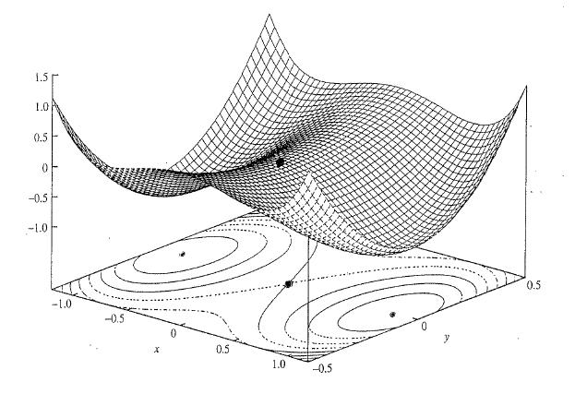

Given information: 1 au = 627.5 kcal/mol = 27.21 eV

