TFY4215 Kjemisk fysikk og kvantemekanikk Spring 2008
Chemical physics Solution to Exercise 3

Base pairs in DNA.

3.
a) For B-DNA, the period is ca 34 Å, and there are 10 P-atoms per period.

b) I have measured these distances in B-DNA (i.e.: as built in Spartan):

Between cytosine (C) and guanine (G):
From H in C to O in G: 1.876 Å
From N in C to H in G: 1.850 Å
From O in C to H in G: 1.881 Å

Between thymine (T) and adenine (A):
From O in T to H in A: 1.984 Å
From H in T to N in A: 1.882 Å

Typical hydrogen bond lengths are slightly shorter than 2 Å. In comparison, ordinary chemical bonds between O and H and between N and H are ca 1 Å.

With “Model - Hydrogen Bonds” combined with “Ball and Wire”, it is easy to see the hydrogen bonds, and thereby localize G-C and A-T base pairs. Here is a G-C base pair in B-DNA:
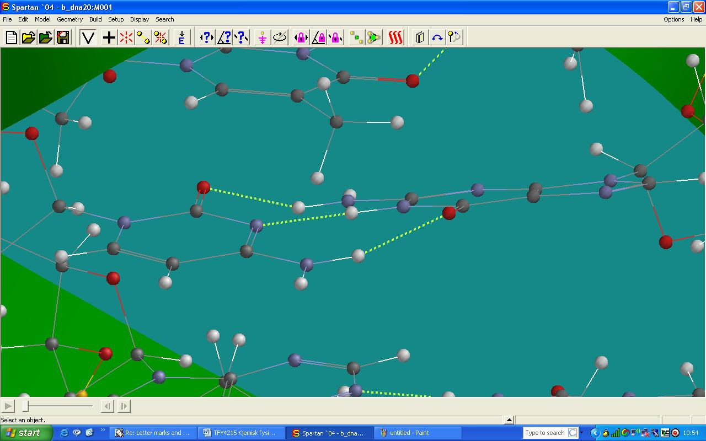

The helical ”outer walls” consist of 2-deoxyribose and phosphate. In the figure below we clearly see two phosphate groups and two carbohydrate groups (fivemembered rings):

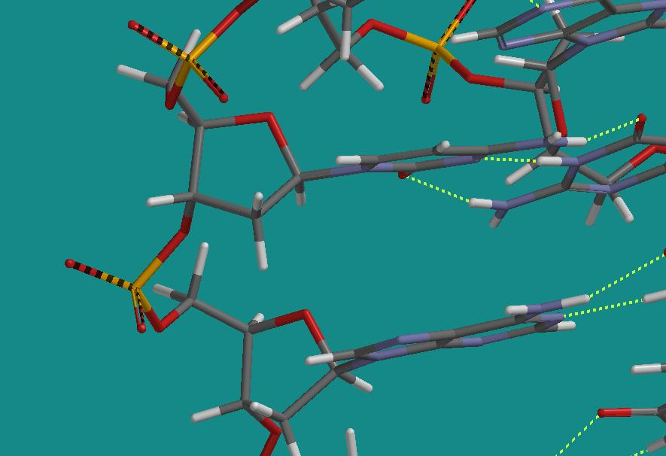

It is not so easy to measure the diameter of the DNA double helix exactly because it is difficult to locate two atoms situated diametrically with respect to each other. In the figure below, B-DNA is oriented with the double helix coming out of the plane. The two small orange balls are Cl-atoms in a Cl₂ molecule where the bond length is set to 24 Å. This seems to be about the size of the diameter of B-DNA.

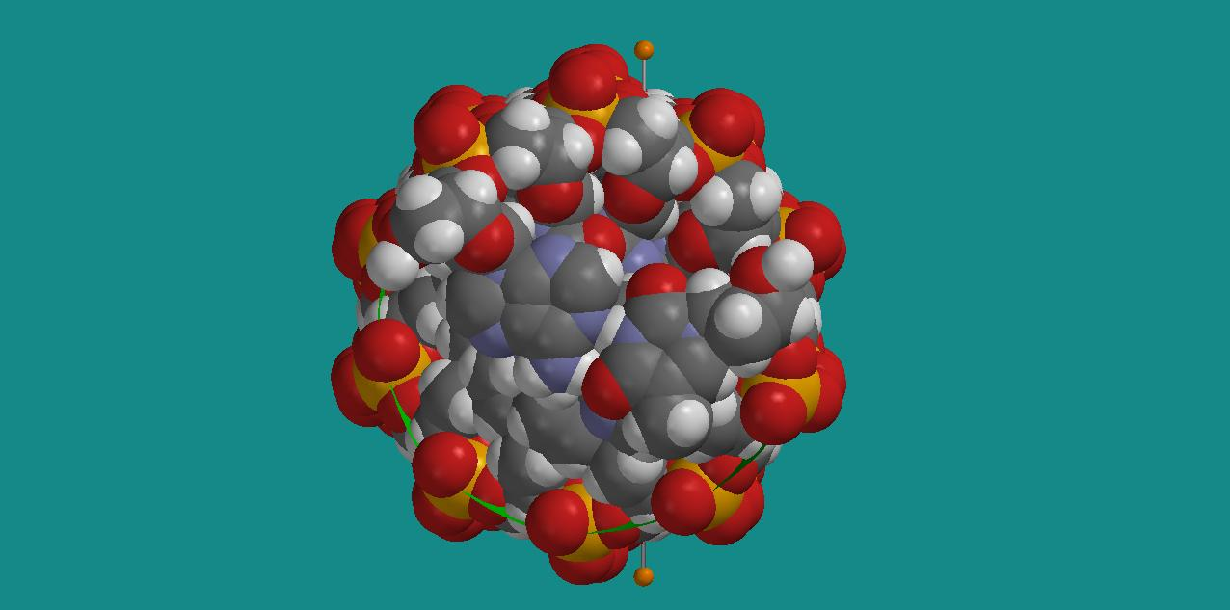

With B-DNA oriented with the double helix in the plane, we can clearly identify two ”grooves”. In the figure below, we have again inserted Cl₂ measuring sticks, showing that the two grooves in B-DNA have widths of 12 and 4 Å, respectively.

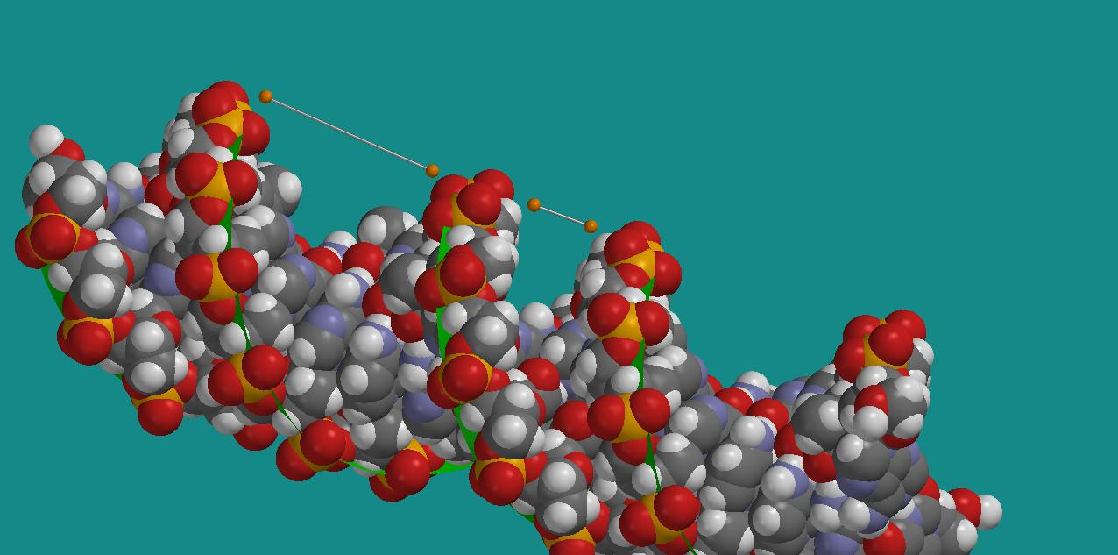
B-DNA: Two grooves of width 12 and 4 Å

c) Relevant atomic masses are:
m(H)=1, m(C)=12, m(O)=16, m(N)=14 and m(P)=31
Hence:
m(PO₄)=95, m(2-deoxyribose)=134, m(A)=135, m(T)=126, m(C)=111 and m(G)=151
Connection of phosphate groups and amino bases to the carbohydrate takes place where the carbohydrate has its OH groups, and in a way such that these 3 OH groups ”vanish”. Therefore, we should subtract the mass of 3 OH-groups for the carbohydrate. Further, one H atom disappears pr base when connecting the groups together. Then, one A-T base pair has mass 259 and one G-C base pair has mass 260. Each “building block” consisting of phosphate + carbohydrate + amino base will then have an average mass of 308. We have two helices, so on the length occupied by one P-atom (per helix) along the DNA molecule, we have a mass of 616.
The mass unit here is the mass of a nucleon, ca 1.67⋅10⁻²⁷ kg. Hence, the mass per length per P-atom is then 616⋅1.67⋅10⁻²⁷ kg = 1.03⋅10⁻²⁴ kg.
In B-DNA, we have 10 P-atoms on a length 34 Å, i.e., 1 P-atom per length (34/10)⋅10⁻⁸ cm. Hence, 2.9⋅10⁸ P-atoms (per spiral) on a length 10 cm, so that a B-DNA molecule of length 10 cm will have a mass 3.0⋅10⁻¹⁶ kg.
Radius ca 12 Å gives a cross section ca 452 Å², and hence a volume ca 0.5 cubic micrometer if the length is 10 cm. In other words, plenty of room for many such molecules within a single cell, provided they are properly “wound up”.

4.
a) Calculations with the Hartree – Fock method and the basis set 3-21G yields:

E(G) = - 536.365253 au
E(C) = - 390.416205 au
E(G-C base pair) = -926.844981 au
Calculated binding energy is therefore:

E_{b} = E(G-C) - E(G) - E(C)
= - 926.844981 + 536.365253 + 390.416205
= - 0.063523 au
= - 39.9 kcal/mol

As mentioned in the exercise text: This is substantially more than what we actually have in nature. Rather than a binding energy per hydrogen bond of 10 – 15 kcal/mol (as found here), we probably have something lik 2 – 5 kcal/mol per hydrogen bond.
Anyway, the calculations still show that we are dealing with a kind of bonds that are much weaker than ordinary covalent bonds and ionic bonds. On
http://www.cem.msu.edu/~reusch/VirtualText/react2.htm
I found a table which provides ”Standard Bond Energies”, i.e., typical bond energies for bonds between different kind of atoms. A typical H-H binding energy is slightly above 100 kcal/mol, and that is also the case for the bond between H and Cl.

b) Calculated distances between O and N in the G – C base pair:

O(G) – N(C) = 2.77 Å (Experiment: 2.91 Å)
N(G) – N(C) = 2.90 Å (Experiment: 2.95 Å)
N(G) – O(C) = 2.87 Å (Experiment: 2.86 Å)

5.
In the figure below, we have a G – C base pair at the bottom, with G to the right and C to the left, and an A – T base pair on top, with A to the right and T to the left:

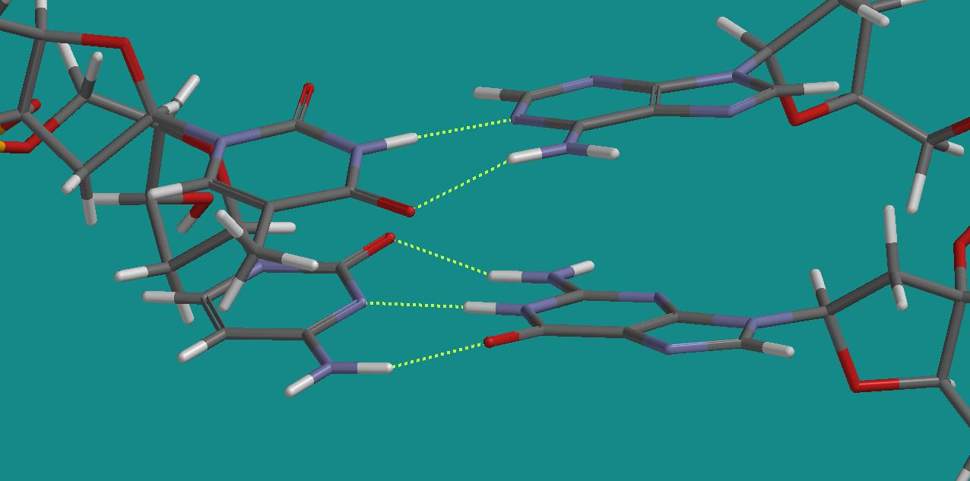

Interchanging C and T will result in a G – T base pair at the bottom and an A – C base pair on top. We see that if we simply translate T downwards, an O on T will “meet” an O on G, and an H on T will meet an H on G, and this does not result in stabilizing hydrogen bonds. In the same manner, by translating C upwards: An H on C will meet an H on A, and an N on C will meet an N on A. Only the O on C and an H on A could possibly result in a hydrogen bond.
These observations are consistent with the fact that we only find base pairs of the type G – C and A – T in natural DNA. However, let us not be too conclusive at this stage: I am sure you can make other combinations that appear to become stable and nice, but of a type that you do not find in nature. So, there are probably other decisive factors as well that we have not discussed in this exercise.

