FY1006 Innføring i kvantefysikk
TFY4215 Kjemisk fysikk og kvantemekanikk
Våren 2009

Appendix to the lecture notes in Chemical physics

Molecular models produced in Spartan
(color code in Figure 9)
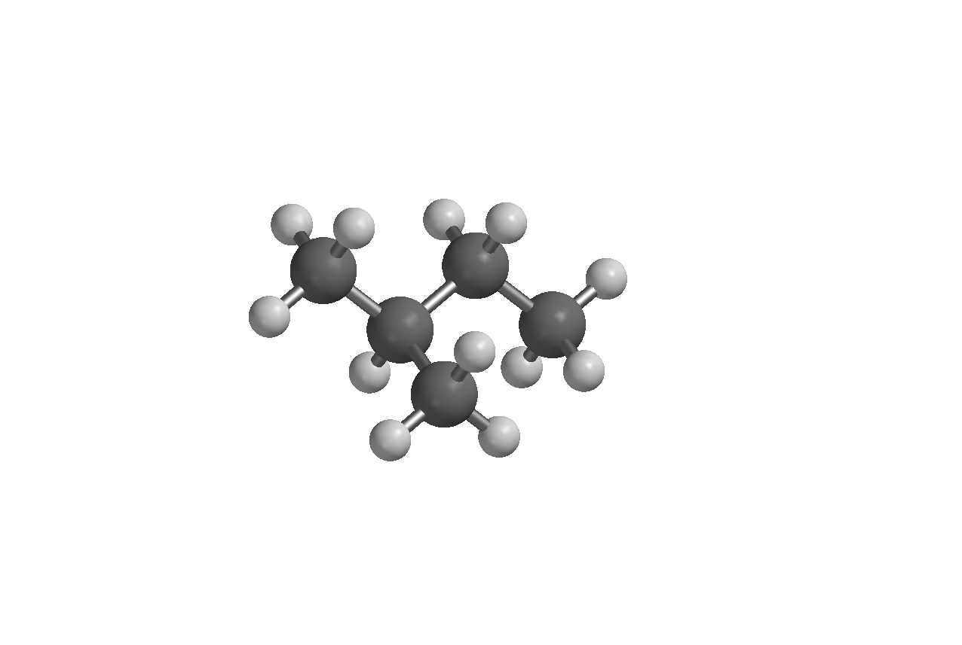
Figure 1: 2-methyl-butane, C₅H₁₂
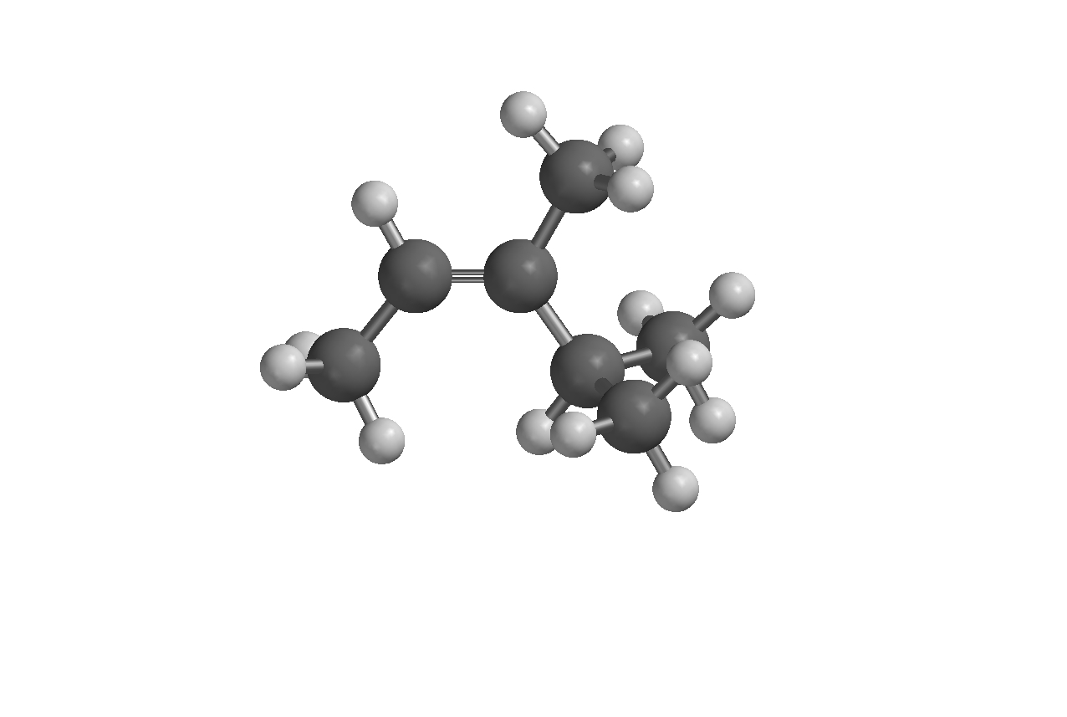
Figure 2: 3,4-dimethyl-2-pentene, C₇H₁₄

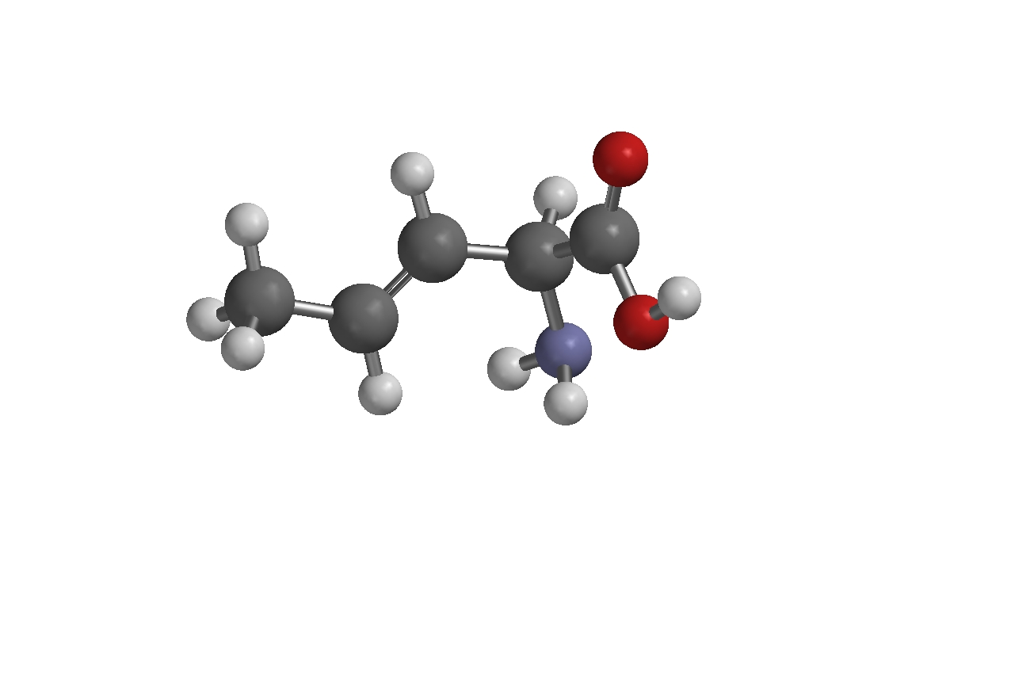
Figure 3: 2-amino-3-pentenoic acid, C₄H₆NH₂COOH

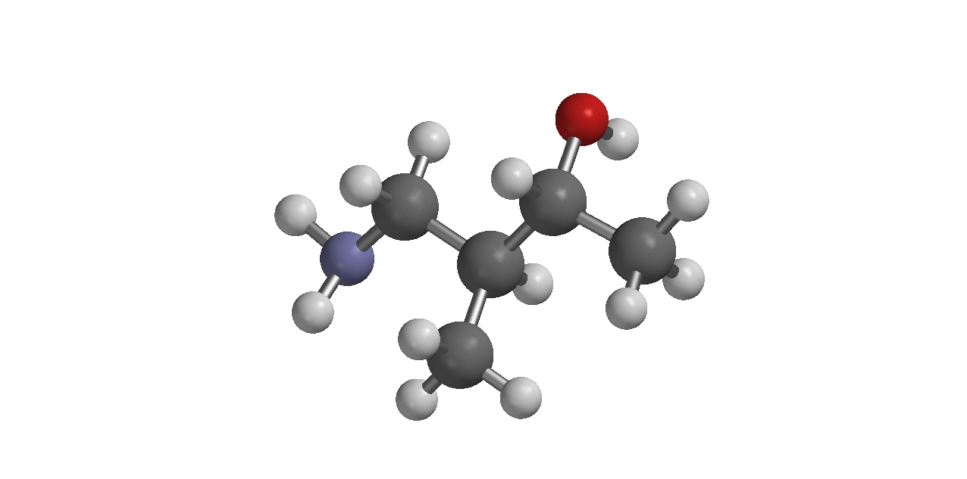
Figure 4: 4-amino-3-methyl-2-butanol, NH₂C₅H₁₀OH
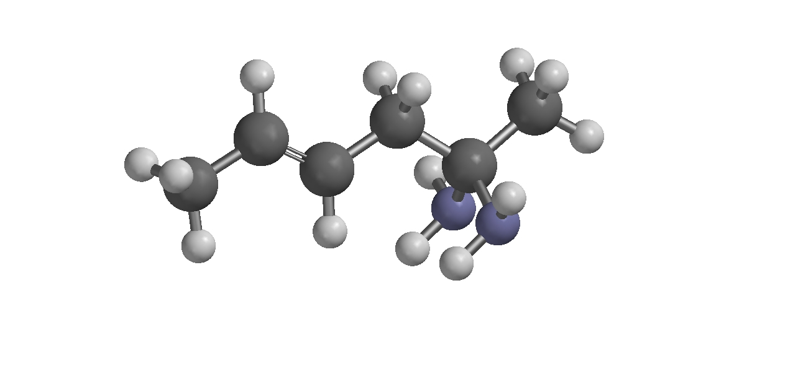
Figure 5: 4-hexene-2,2-diamine, (NH₂)₂C₆H₁₀

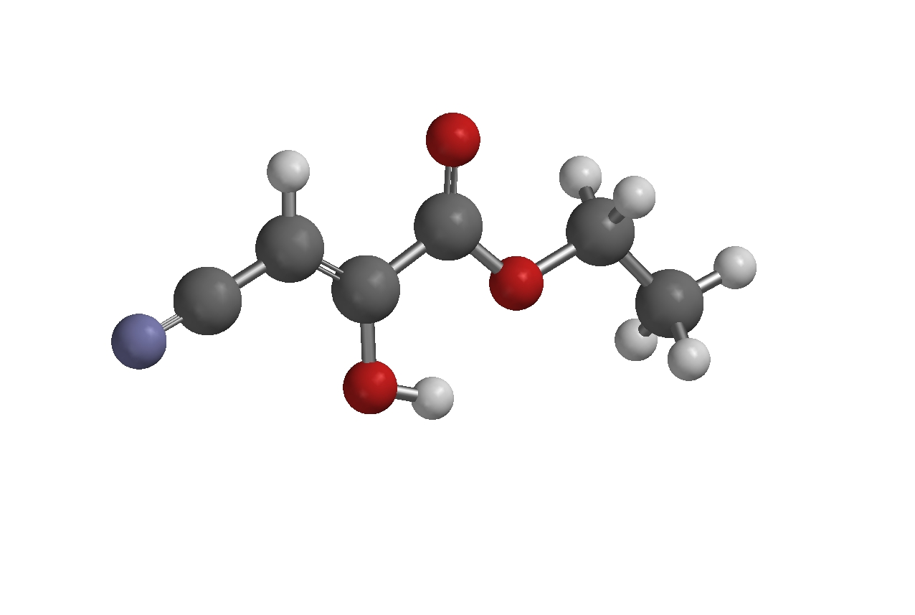
Figure 6: Ethyl-4-cyano-3-hydroxy-2-butenoate, NC₃HOHCOOC₂H₅
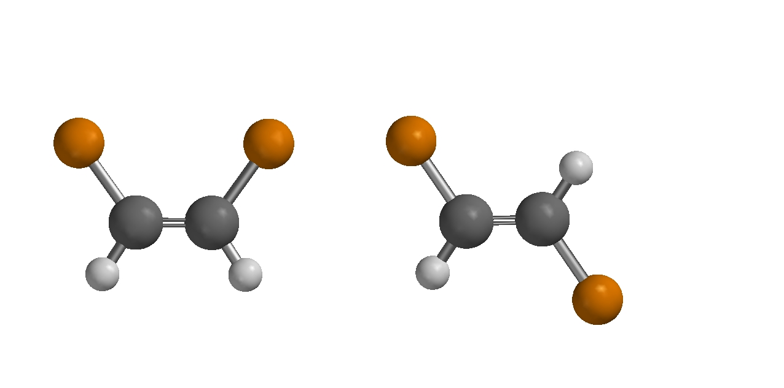
Figure 7: cis- and trans-1,2-dichloroethene, C₂H₂Cl₂

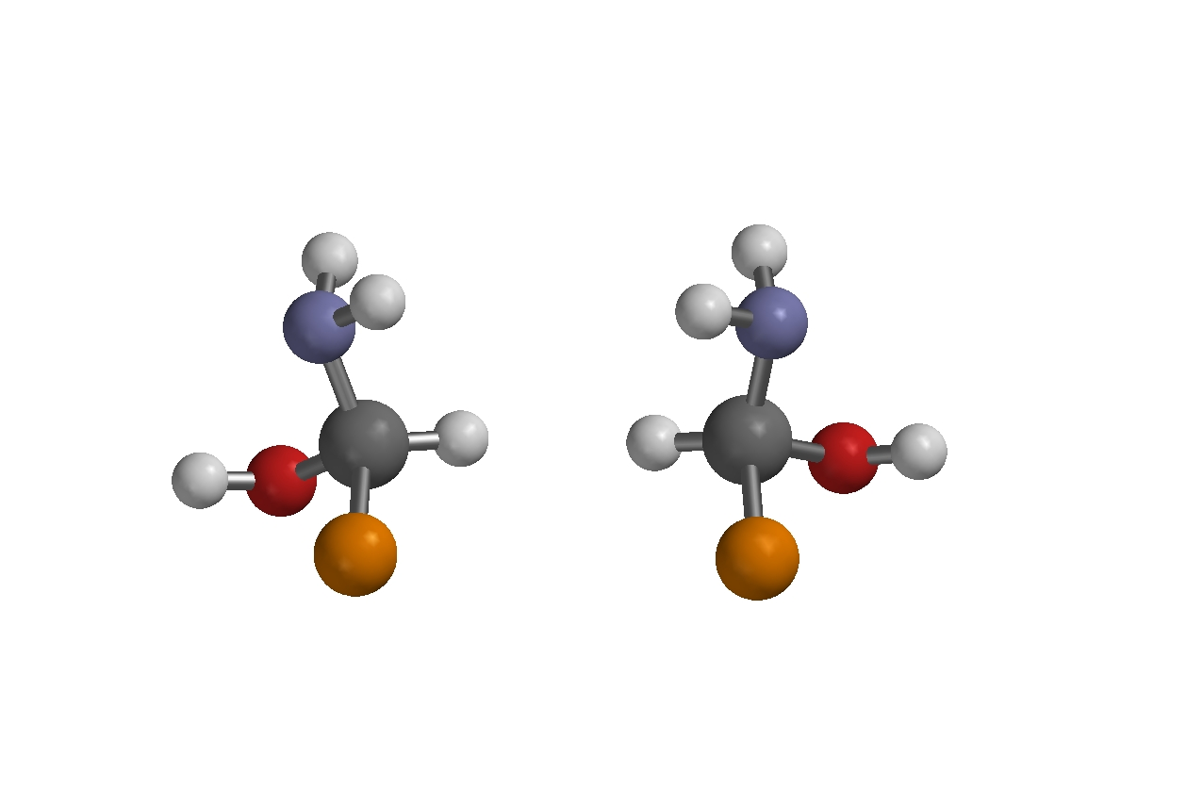
Figure 8: R- and S-amino-chloro-methanol, HCNH₂OHCl (R to the left)

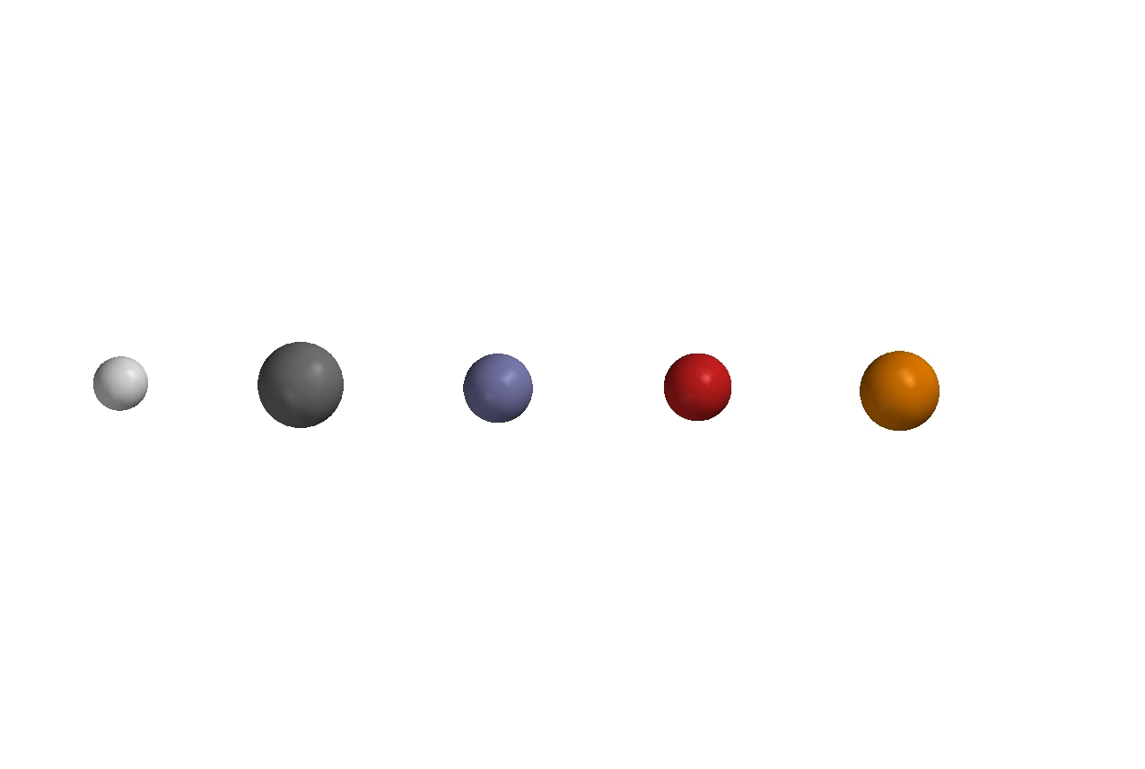

H C N O Cl

Figure 9: Color code

