FY1006 Innføring i kvantefysikk og TFY4215 Kjemisk fysikk og kvantemekanikk
Spring 2010
Chemical physics Solution to Exercise 1

Ethene.

6. With the Hartree – Fock method and the basis set 3-21G, one obtains an equilibrium geometry for ethene with the bond lengths C-H = 1.074 Å and C-C = 1.315 Å, and the bond angles HCH = 116.2º and HCC = 121.9º. Compared with the experimental values C-H = 1.076 Å, C-C = 1.33 Å, HCH = 116.6º and HCC = 121.7º, this yields a mean error of

This relatively small deviation between theory and experiment is somewhat accidental, I assume. After I made the exercise text, I found alternative experimental values, for example 1.339 Å, 1.085 Å and 117.8º for the bond lengths C-H and C-C and the bond angle HCH, respectively. With these values, the mean error becomes ca 1.2%. Note that the bond angles HCH and HCC are not independent in such a symmetric molecule (see point 7j below). Strictly speaking, we should therefore remove one of the terms in the sum above and divide by 3 instead of 4. For example, if we remove the last term (i.e. the error in the bond angle HCC), the mean errors become 0.6 and 1.4%, respectively, with the two mentioned sets of experimental values. Alternatively, we could remove the third term (i.e. the error in the bond angle HCH), which will give a mean error of 0.5 and 1.2%, respectively. In other words: Roughly the same mean error, independent of which “method” we use.

7.
a) With the basis set 3-21G (or, to be precise, 3-21G(*), in the case you encounter similar things later in your life), we have, as mentioned in the exercise text, included two s-functions for each H-atom and three s- and six p-functions for each C-atom. All together 4 × 2 + 2 × 9 = 26 basis functions. This means that each molecular orbital (MO) is expressed as a linear combination of these 26 basis functions ,
with coefficients that denote the ”contribution” from basis function number μ to MO number i. ”To solve the quantum mechanical problem” for a given molecule then means finding the set of coefficients such that the total energy of the molecule becomes as low as possible.
Carbon has atom number 6, i.e. 6 electrons, while hydrogen has 1 electron. Hence, ethene has a total of 16 electrons.

b) Inspection of c2h4.spartan with Display – Output shows (at least in my computation) that the program used 3 iterations to optimize the geometry:

Point Group = DNH Order = 2 Nsymop = 8
This system has 3 degrees of freedom
Hessian from MMFF94 calculation used.
Max. Max. Neg.
Cycle Energy Grad. Dist. Eigen
1 -77.5981973 0.01855 0.00897
2 -77.6008962 0.00331 0.00021
3 -77.6009879 0.00015 0.00000

M001

E(HF) = -77.6009879 a.u.

A starting geometry with 1.815 Å between the two C atoms results in a need of 11 iterations to optimize the geometry. I made an even worse starting geometry by changing bond angles, bond lengths and torsional angles to pretty bad values. Still, the program used only 14 iterations to optimize the geometry.

c) Optimization of the geometry and computation of the vibrational frequencies took 1.3 CPU-seconds:

Reason for exit: Successful completion
HF Program CPU Time : 000:00:01.3
HF Program Wall Time: 000:00:01.5

In a Hartree – Fock calculation, the CPU time will roughly scale with the number of basis functions raised to the fourth power. Here, we have relatively few basis functions, and in addition a symmetrical molecule, so that the number of degrees of freedom becomes small (see point 6 above and point 7j below) and the computation time short. With an increasing number of atoms and lack of symmetry, it soon becomes a significant numerical job.

d) The two C atoms lie on the z axis, the whole molecule in the xz plane:

Cartesian Coordinates (Angstroms)
Atom X Y Z
--------- ------------- ------------- -------------

1 H H1 0.9115633 0.0000000 -1.2253162
2 C C1 0.0000000 0.0000000 -0.6575621
3 C C2 0.0000000 0.0000000 0.6575621
4 H H2 -0.9115633 0.0000000 -1.2253162
5 H H3 0.9115633 0.0000000 1.2253162
6 H H4 -0.9115633 0.0000000 1.2253162

e) Ethene has 16 electrons. According to the Pauli principle, we can only have one electron in each single particle state. In each MO, we may have one electron with spin “up” and one electron with spin “down”. Hence, we fill 8 MOs with 16 electrons. The ground state corresponds to the situation where we occupy the 8 MOs with the lowest energy, two electrons in each of these. The HOMO orbital is the ”Highest Occupied Molecular Orbital”, i.e., the one among the occupied MOs with the highest energy, hence MO number 8. The LUMO orbital is the ”Lowest Unoccupied Molecular Orbital”, i.e., the one among the unoccupied orbitals with the lowest energy, hence MO number 9. Orbital ”HOMO–n” is therefore MO number 8 – n.

f) The orbital HOMO looks like this:

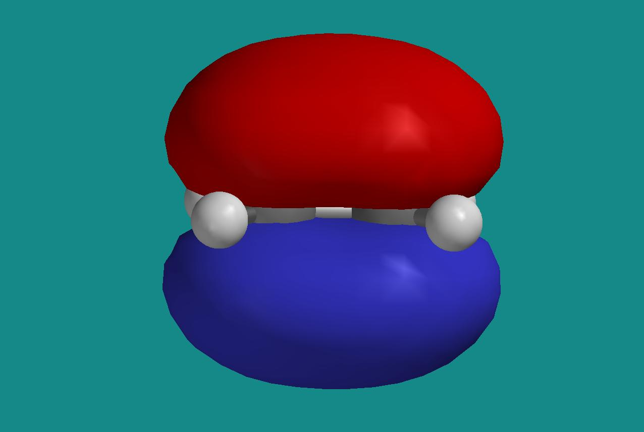

The red half represents a surface with constant negative value of the orbital, the blue half a surface with the corresponding positive value. With the molecule localized in the xz plane, it is clear that we have here p_{y} orbitals centered on the C atoms that contribute to the MO. This is consistent with the coefficients for MO number 8 in the output file:

MO: 6 7 8 9 10
Eigenvalues: -0.59082 -0.49887 -0.37970 0.18659 0.29869
(ev): -16.07714 -13.57503 -10.33206 5.07744 8.12775

Ag B3g B3u B2g Ag
1 H1 S 0.11943 -0.17957 0.00000 0.00000 0.01584
2 H1 S 0.11014 -0.15673 0.00000 0.00000 0.96355
3 C1 S 0.00829 0.00000 0.00000 0.00000 0.09064
4 C1 S -0.02161 0.00000 0.00000 0.00000 -0.03106
5 C1 PX 0.00000 -0.26064 0.00000 0.00000 0.00000
6 C1 PY 0.00000 0.00000 0.32177 0.30232 0.00000
7 C1 PZ -0.36461 0.00000 0.00000 0.00000 0.12964
8 C1 S 0.02856 0.00000 0.00000 0.00000 -1.39568
9 C1 PX 0.00000 -0.27725 0.00000 0.00000 0.00000
10 C1 PY 0.00000 0.00000 0.37234 0.76201 0.00000
11 C1 PZ -0.22153 0.00000 0.00000 0.00000 0.63273
12 C2 S 0.00829 0.00000 0.00000 0.00000 0.09064
13 C2 S -0.02161 0.00000 0.00000 0.00000 -0.03106
14 C2 PX 0.00000 0.26064 0.00000 0.00000 0.00000
15 C2 PY 0.00000 0.00000 0.32177 -0.30232 0.00000
16 C2 PZ 0.36461 0.00000 0.00000 0.00000 -0.12964
17 C2 S 0.02856 0.00000 0.00000 0.00000 -1.39568
18 C2 PX 0.00000 0.27725 0.00000 0.00000 0.00000
19 C2 PY 0.00000 0.00000 0.37234 -0.76201 0.00000
20 C2 PZ 0.22153 0.00000 0.00000 0.00000 -0.63273
21 H2 S 0.11943 0.17957 0.00000 0.00000 0.01584
22 H2 S 0.11014 0.15673 0.00000 0.00000 0.96355
23 H3 S 0.11943 0.17957 0.00000 0.00000 0.01584
24 H3 S 0.11014 0.15673 0.00000 0.00000 0.96355
25 H4 S 0.11943 -0.17957 0.00000 0.00000 0.01584
26 H4 S 0.11014 -0.15673 0.00000 0.00000 0.96355

Only for μ = 6, 10, 15 and 19, MO nr 8 has non-zero coefficients. These four are p_{y} orbitals on the two carbon atoms C1 and C2. We further note that the two C atoms contribute with the same sign for corresponding atomic orbitals (6 and 15, 10 and 19, respectively). This results in a so-called “bonding” MO.

g) LUMO is MO nr 9, it looks like this:

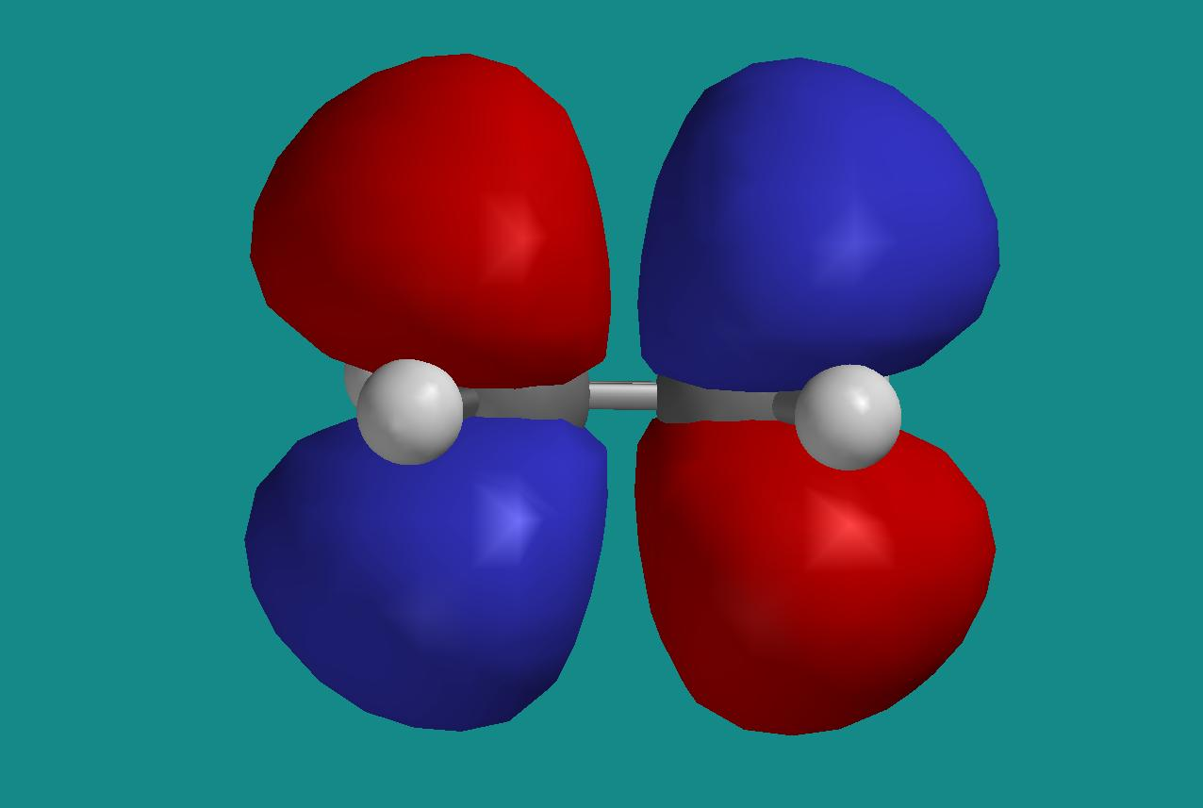

From the output file, we see that LUMO is made up of the same four p_{y} orbitals as HOMO, but this time with opposite sign for corresponding atomic orbitals on the two C atoms. This results in a so-called “anti-bonding” MO. LUMO has “nodal planes” (i.e. planes where LUMO is zero) both in the xz and in the xy plane, HOMO has a nodal plane only in the xz plane. This is consistent with what you have learnt earlier in the course, namely that the energy of the orbitals increases with an increasing number of zeroes.

HOMO–7 is MO number 1, i.e., the one with the lowest energy. It looks like this:
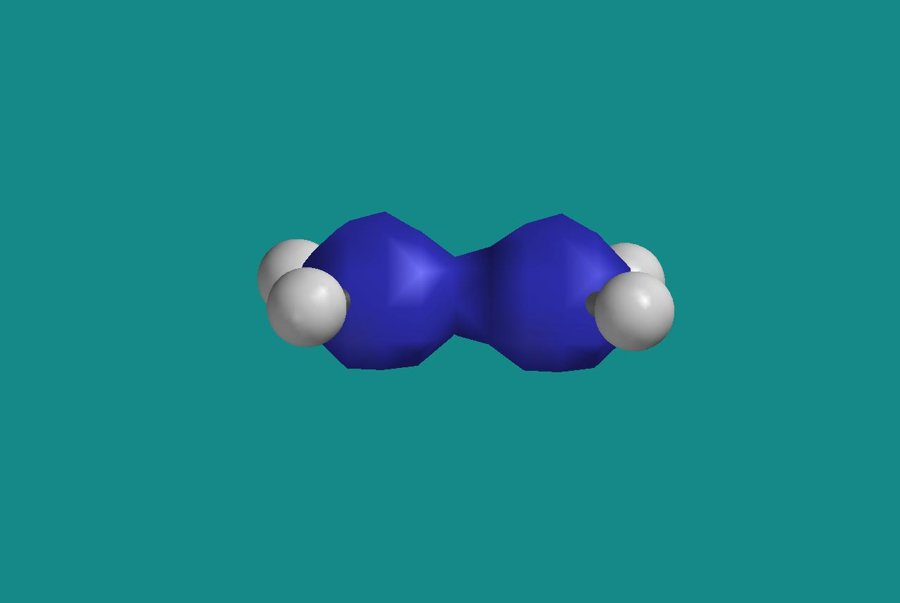
It looks as if this MO is built from s-orbitals on carbon, and this is consistent with the fact that the coefficients and are the dominating ones in MO number 1:

MO: 1 2 3 4 5
Eigenvalues: -11.16625 -11.16605 -1.03819 -0.78870 -0.64657
(ev): -303.84929 -303.84375 -28.25049 -21.46163 -17.59397

Ag B1u Ag B1u B2u
1 H1 S -0.00179 0.00028 0.07766 -0.13828 0.14663
2 H1 S 0.00968 -0.00805 0.00398 -0.06692 0.10789
3 C1 S 0.69758 -0.69791 -0.16680 0.12774 0.00000
4 C1 S 0.06538 -0.07106 0.18317 -0.13113 0.00000
5 C1 PX 0.00000 0.00000 0.00000 0.00000 0.28001
6 C1 PY 0.00000 0.00000 0.00000 0.00000 0.00000
7 C1 PZ -0.00169 -0.00207 0.11052 0.14357 0.00000
8 C1 S -0.03146 0.06770 0.36822 -0.41834 0.00000
9 C1 PX 0.00000 0.00000 0.00000 0.00000 0.19335
10 C1 PY 0.00000 0.00000 0.00000 0.00000 0.00000
11 C1 PZ 0.00440 0.01563 0.01587 0.06341 0.00000
12 C2 S 0.69758 0.69791 -0.16680 -0.12774 0.00000
13 C2 S 0.06538 0.07106 0.18317 0.13113 0.00000
14 C2 PX 0.00000 0.00000 0.00000 0.00000 0.28001
15 C2 PY 0.00000 0.00000 0.00000 0.00000 0.00000
16 C2 PZ 0.00169 -0.00207 -0.11052 0.14357 0.00000
17 C2 S -0.03146 -0.06770 0.36822 0.41834 0.00000
18 C2 PX 0.00000 0.00000 0.00000 0.00000 0.19335
19 C2 PY 0.00000 0.00000 0.00000 0.00000 0.00000
20 C2 PZ -0.00440 0.01563 -0.01587 0.06341 0.00000
21 H2 S -0.00179 0.00028 0.07766 -0.13828 -0.14663
22 H2 S 0.00968 -0.00805 0.00398 -0.06692 -0.10789
23 H3 S -0.00179 -0.00028 0.07766 0.13828 0.14663
24 H3 S 0.00968 0.00805 0.00398 0.06692 0.10789
25 H4 S -0.00179 -0.00028 0.07766 0.13828 -0.14663
26 H4 S 0.00968 0.00805 0.00398 0.06692 -0.10789

HOMO–6, i.e. MO number 2, is essentially the antisymmetric version of MO number 1:

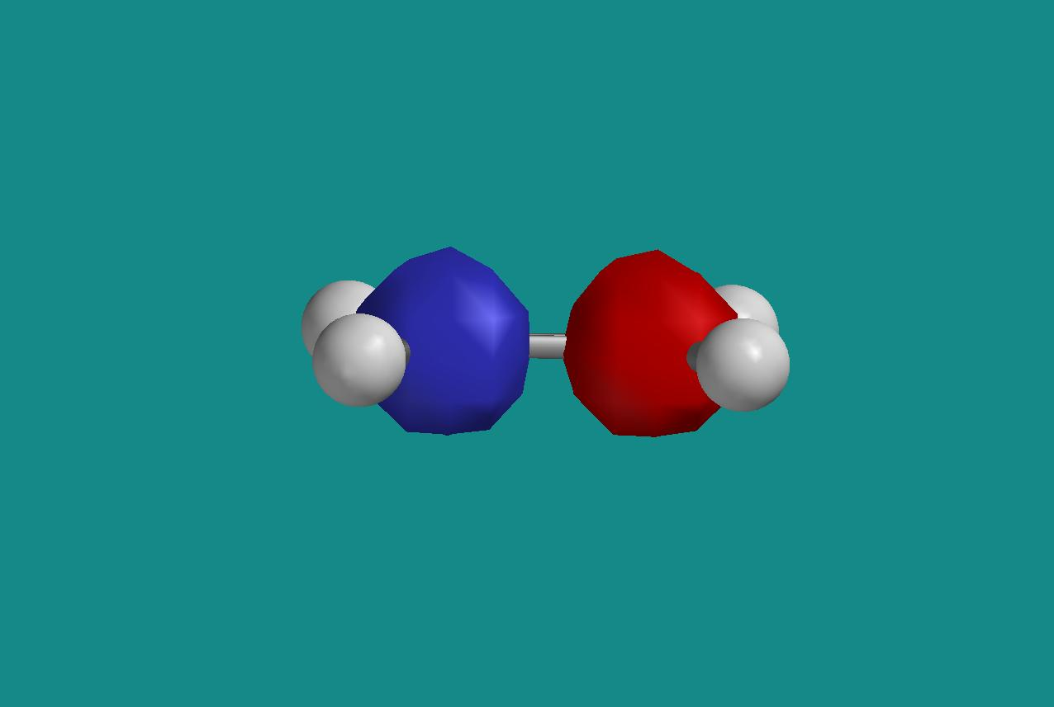

We see from the coefficients in the output file that this orbital is also made from s-functions on carbon, with a positive sign on one of them and a negative sign on the other. In MO number 2, the xy plane is a nodal plane, in MO number 1, we have no nodal planes. Again, an example of a bonding and an anti-bonding MO, where the latter has the highest energy of the two.

HOMO–5, i.e., MO number 3 looks like this:

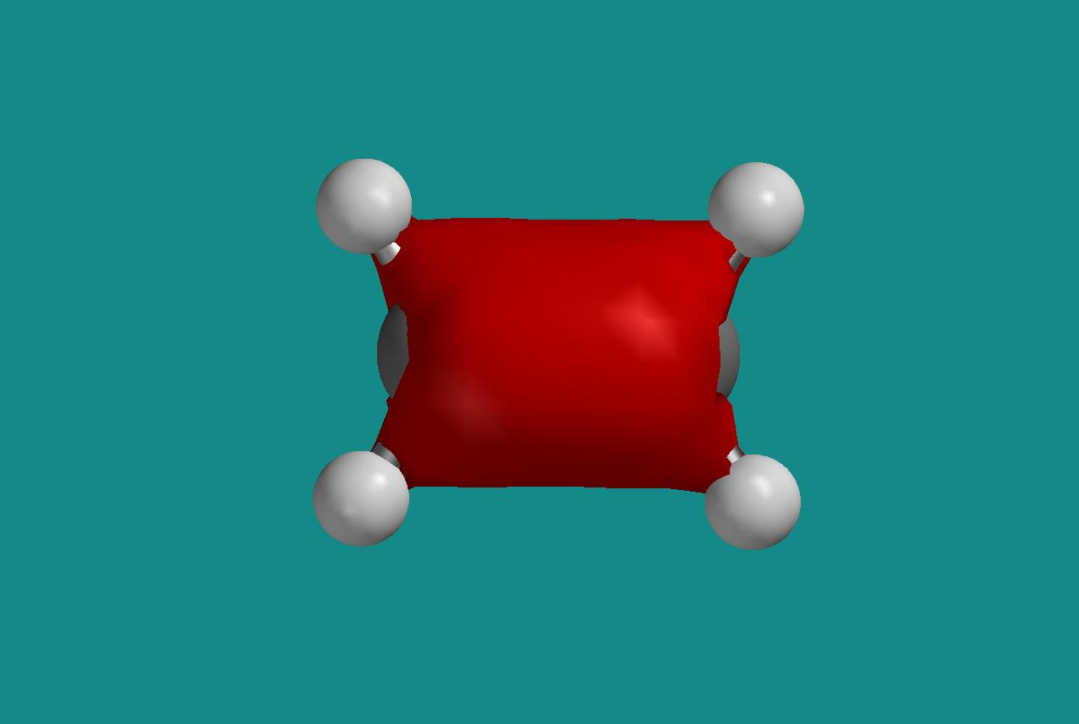

We see that this is an orbital with even parity (so-called ”gerade”, as opposed to ”ungerade” for an orbital with odd parity), but apart from that, it may be difficult to determine visually which atomic orbitals that contribute. Inspection of the coefficients in the output file shows that it is primarily s-orbitals on carbon (and partly on hydrogen) and p_{z}-orbitals on carbon that are the “building blocks” in this molecular orbital. Hence, this MO is the one coming closest to the so-called σ-orbital in Ekstraøving 1.

h) Even parity (“gerade”) for an MO means that it has the same sign in position r and –r, while odd parity (”ungerade”) for an MO means that is has the opposite sign in r and –r. From the figures in g) above, we can see that LUMO, HOMO–7, and HOMO–5 are all of the type gerade, whereas HOMO and HOMO–6 are of the type ungerade. This is consistent with the symmetry notation given in the output file, for example B2g, B3u and so on, right above the column with the coefficients .

i) The surface with constant electron density and a color code for the electrostatic potential looks like this:
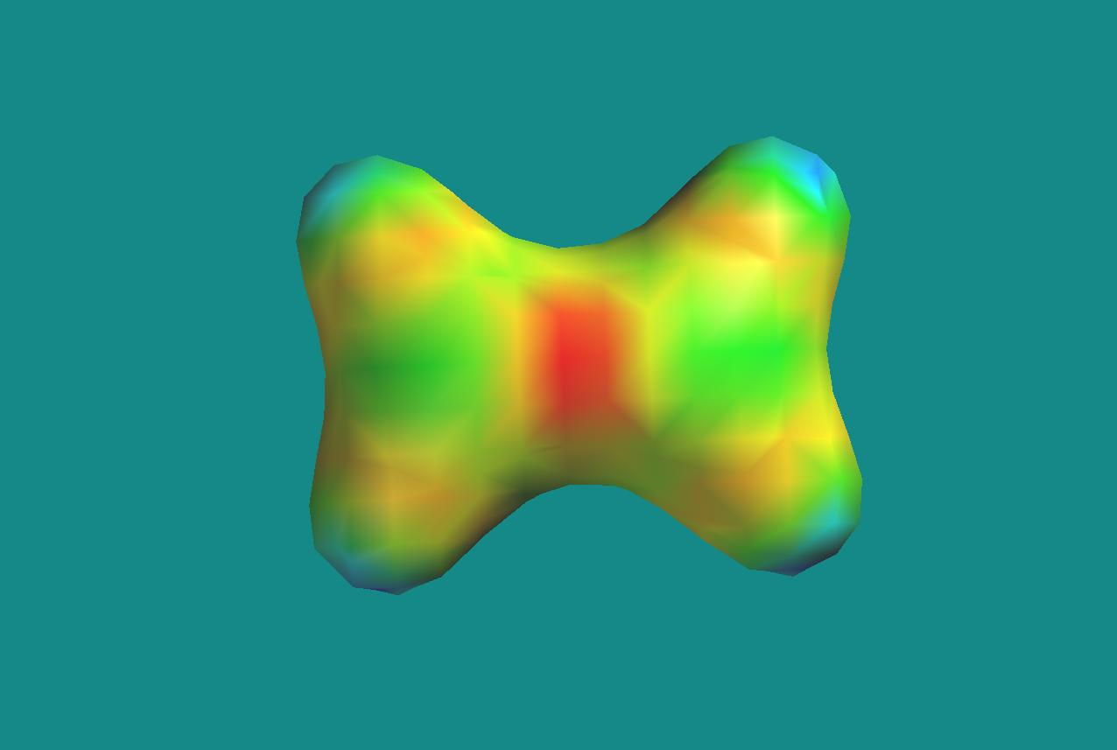

Not surprisingly, we find the region with the lowest value of the potential (red) centrally located in the double bond between the two carbon atoms. This is a region that is “rich in electrons”, and hence will be attracted by electrophile (i.e. “poor in electrons”) regions in possible reaction partners.

j) Take, for example, a coordinate system with the origin in the position of the center of mass of the molecule, i.e., half way between the two C atoms. Assume next that one C atom lies on the z axis, in the position (0, 0, z_{C}), and also that one of the H atoms nearest to this C atom lies in the xz plane, in the position (x_{H}, 0, z_{H}). The symmetry constraint now automatically fixes the positions of the remaining four atoms: the second C atom in position (0, 0, -z_{C}) and the remaining three H atoms in positions (x_{H}, 0, -z_{H}), (-x_{H}, 0, z_{H}), and (-x_{H}, 0, -z_{H}), respectively. In other words, it is sufficient with three independent coordinates to specify the complete geometry of the molecule.
Alternatively, we might have used 1) the distance from the origin to one of the C atoms: r_{C} = |z_{C}|, 2) the distance form this C atom to one of the H atoms: r_{C-H} = (x_{H}² + (z_{H}-z_{C})²)^{1/2}, and 3) the angle θ between the (distance) vector from the origin to the C atom and the vector from the C atom to the H atom, given by: cos θ = r_{C}·r_{C-H}/r_{C}r_{C-H}. If we compare with point 6 above, this corresponds to r_{C} = (C-C)/2, r_{C-H} = (C-H), and θ = (180º - HCC) = (HCH)/2.
You can easily imagine other alternative choices of independent coordinates!
The bond angles HCH and HCC are therefore not independent in a symmetric molecule like the present one: With all the six atoms in the same plane, and furthermore a “symmetric” positioning of all four H atoms with respect to the two C atoms, the angle HCH is fixed (as 360º – 2 × HCC) as soon as the angle HCC is known, and vice versa.
The geometry of the molecule, initially given in terms of 12 coordinates (i.e., reduced form 18, i.e., the x, y, and z values of each of the 6 atoms, to 12, since we are here only interested in the internal structure, and not the overall position and orientation of the molecule), is in other words completely determined by only 3 so called internal coordinates, for example two bond lengths and one bond angle. The symmetry fixes the rest of the coordinates.

8.
a) We will transform the wave number region from 4000 to 500 cm⁻¹ into corresponding regions for the wave length, the frequency, and the energy of the absorbed light. We have the relations , and between wave number k, wave length λ, light velocity c, frequency f, energy E and Planck’s constant h. Hence:
(4000 to 500) cm⁻¹ for k corresponds to (15.7 to 126) μm for λ, (2387 to 19100) GHz for f, and (10 to 79) meV for E.
In comparison, we find visible light in the wave length region (0.40 to 0.76) μm. In other words, the vibrational frequencies in the molecule correspond to wave lengths in the infrared region.

b) In our calculation, we find the strongest vibrational band at 1116 cm⁻¹. This value must be scaled with a factor 0.85 to give the experimental value of 949 cm⁻¹. The factor of 0.85 is even smaller than what one usually must use for Hartree–Fock evaluated frequencies (around 0.90), but there is no doubt we have localized the “correct” vibrational mode.

c) Illustration of the vibrational movement for the frequency 1116 cm⁻¹:
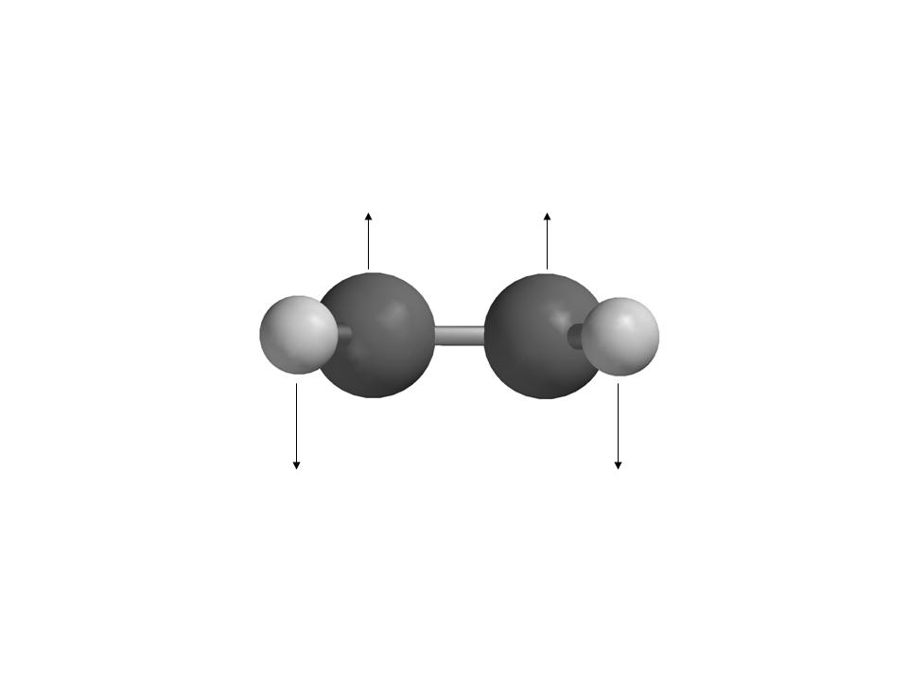
If we consider each H-atom as a positive point charge and each C-atom as a negative point charge, it should be clear that this vibrational movement represents an oscillating electric dipole. Thus, this vibration can be excited by the oscillating electric field in the incoming electromagnetic wave.
The band at 1522 cm⁻¹ is an example of an IR inactive mode. The corresponding vibrational movement takes place in the plane of the molecule (the xz plane) and may be illustrated like this:
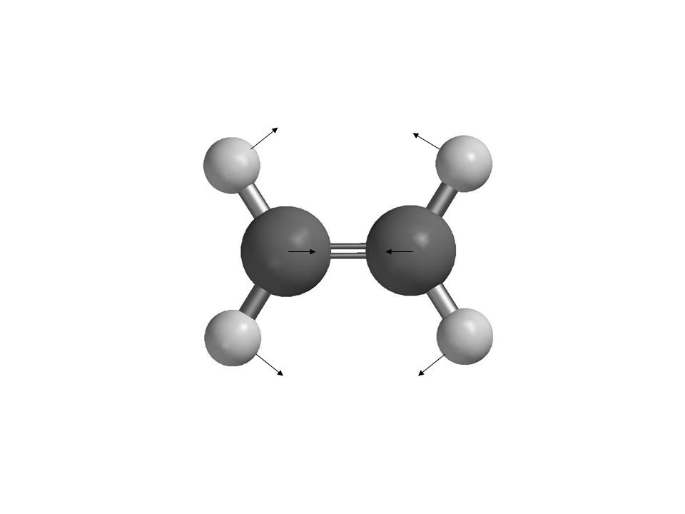
We see that this vibration does not correspond to an oscillating electric dipole – the electric dipole moment of the molecule is zero at all times throughout the vibrational movement. Hence, this mode will not be excited by the oscillating electric field in the incoming electromagnetic wave.

9. There are 3 different isomers of dichloro ethene:

1,1-dichloro ethene:
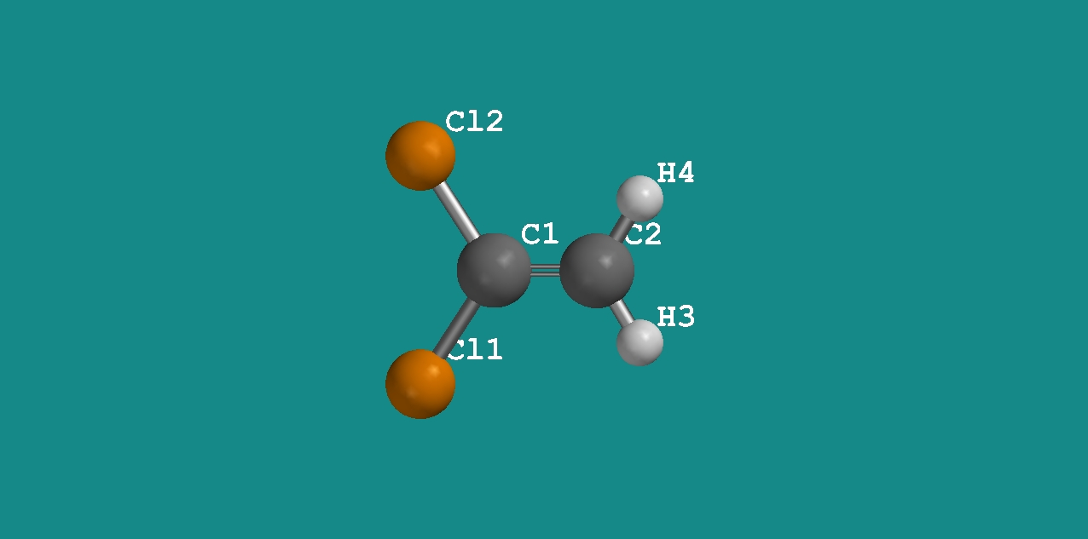

cis-1,2-dichloro ethene:
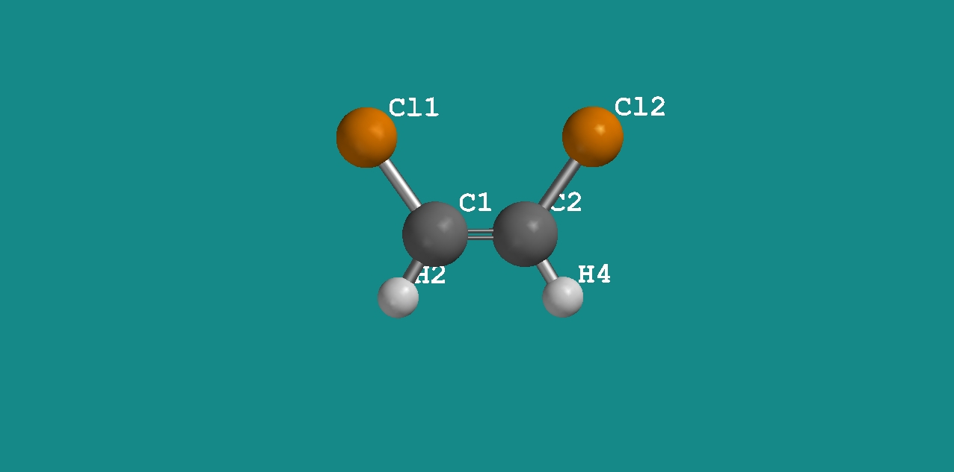

trans-1,2-dichloro ethene:
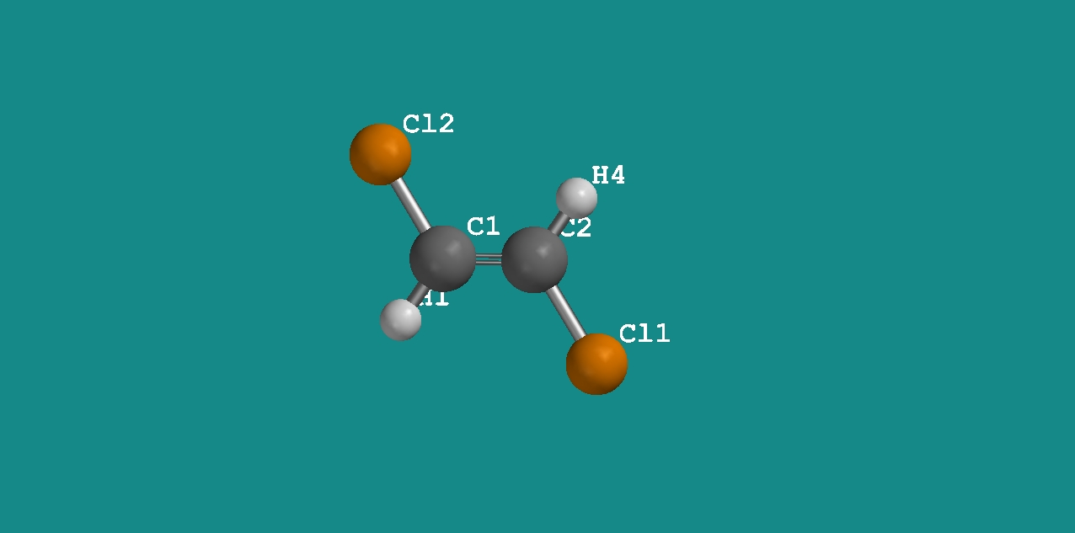

Energies on the HF/3-21G level:

1,1-dichloro ethene: -991.236602 au
cis-1,2-dichloro ethene: -991.240804 au
trans-1,2-dichloro ethene: -991.241122 au

Hence, these computations predict that trans-1,2-dichloro ethene is the most stable isomer, 0.2 kcal/mol more stable than cis-1,2-dichloro ethene, and 2.8 kcal/mol more stable than 1,1-dichloro ethene. This order of stability would have been guessed in classical terms, regarding the atoms as point charges: Decreasing energy with increasing distance between equal atoms, which will repel each other.
However, such simple classical thinking does not always work equally well!

10.
I obtained the following Hartree-Fock energies for the molecules involved:

Pentane: -195.2515601 au
Heptane: -272.8897730 au
Ethene: -77.6009879 au

This yields a reaction energy for the reaction ”pentane + ethene → heptane” of –0.037225 au, or –23.4 kcal/mol. This is actually surprisingly close to the experimentally measured polymerization energy of –25 kcal/mol.

