FY1006 Innføring i kvantefysikk og TFY4215 Kjemisk fysikk og kvantemekanikk
Spring 2012
Chemical physics Solution to Exercise 2

S_{N}2 reaction.

2.
a) Surface with constant electron density for the molecule ClCH₃:
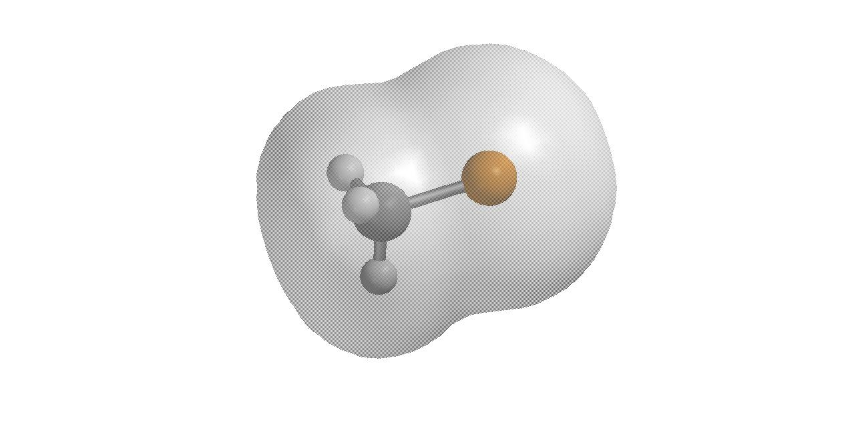
This provides no information concerning where a nucleophile will ”attack”.

b) The same surface, but with variations in the electrostatic potential color coded (red = low potential, blue = high potential):
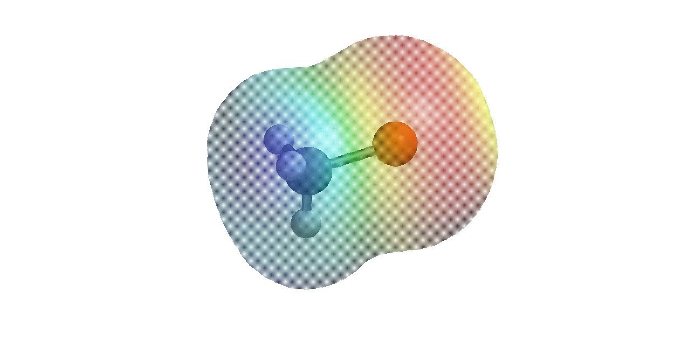
A nucleophile will react on the side where the potential is high, in other words, on the methyl side of the molecule.

c) Calculated dipole moment for ClCH₃ is 2.31 debye, as much as 24% larger than the experimental value of 1.870 debye. In the unit Cm, 2.31 debye is 7.71⋅10⁻³⁰ Cm, which may be written as 0.48 eÅ, where e denotes the elementary charge and Å the length unit angstrom. If we imagine Cl as a negative point charge –q and the methyl group as the corresponding positive point charge q separated by a distance ca 2 Å, the calculated dipole moment corresponds to q = 0.24 e. This gives you an idea of how polar the molecule is.

d) The energy of ClCH₃ is calculated to be -496.79500 au and the energy of Br- is calculated to be -2560.29976 au. The total energy of the reactants is therefore -3057.09476 au. Transformation to the unit kcal/mol is done by multiplying with 627.51, which yields
-1918357.53 kcal/mol.

3.
a) There is no unique recipe for calculating the charge belonging to the different atoms in a molecule: Most of the MOs are ”delocalized”, i.e., they are made up of atomic basis functions from several atoms. Hence, one cannot really say that a specific electron belongs to a particular atom. Nevertheless, one can of course try to assign the electrons to the atoms in the molecule according to a certain algorithm, and this is the basis for how SPARTAN evaluates atomic charges.
In the modeled reaction, we see that the calculated charge on Br is close to -1 (actually –e) as long as the bromide ion is far away from the methyl group. This makes sense, because the bromide ion, when it is alone, has charge -1. Similarly, the chloride ion has a charge that approaches -1 towards the end of the modeled reaction, which makes sense for the same reason: A free chloride ion has charge -1. The charge on the halogen, when it is “normally bonded” to the carbon atom – about -0.20 – shows that the molecule is polar, with a significant surplus of negative charge near the halogen atom. The crossover from -1 to -0.20 (and vice versa) takes place, not surprisingly, when passing the transition state at C-Br = 2.6 Å.

b) At C-Br = 3.2 Å, we have a stable complex with the bromide ion coordinated to the carbon atom of ClCH₃. Here, the bond length between C and Cl is 1.87 Å, only 0.06 Å more than in the “lonely” molecule ClCH₃. Coordination of Br- on the “backside” has resulted in a slight weakening of the bond between C and Cl, but not to an extent that we can say it has been broken.
The complex at C-Br = 3.2 Å has a total energy of -3057.11447 au. This is 0.01971 au less than the energy of the two reactants. Thus, the complexation energy is -12.4 kcal/mol. (Note: If you entered the energy E into the SPARTAN spreadsheet in the unit kcal/mol, you will see that the energy of this complex is -1918369.90 kcal/mol. This is a result of using the conversion factor 627.51 and not 627.5. With the factor 627.5, one gets -1918339.33 kcal/mol. So here, there was a certain risk of obtaining a far too large complexation energy of about -43 kcal/mol, if one used the conversion factor 627.5 in 2d, and then simply reading off the energy in the unit kcal/mol from the spreadsheet.)

c) The energy curve passes a maximum at C-Br = 2.6 Å. From the shape of the fitted curve, it may look as if the transition state (TS) lies somewhere between 2.5 and 2.6 Å for the C-Br distance.
The energy difference between the stable complex at C-Br = 3.2 Å and the energy maximum at C-Br = 2.6 Å is 6.8 kcal/mol, which is therefore the calculated activation energy E_{a}. At room temperature (where k_{B}T is about 0.6 kcal/mol), this corresponds to a Boltzmann factor exp(-E_{a}/k_{B}T) of the order 10⁻⁵. This means that a given collision between Br- and ClCH₃ has a rather small probability of resulting in the modeled reaction. But then we must remember that molecules typically will collide very often in a gas or a liquid, perhaps thousands or even millions of times per second. Then it becomes likely, maybe even close to certain, that a particular ClCH₃ molecule will complete the desired reaction with one or the other Br- during a second or three. And correspondingly, of course: A specific Br- anion will most likely complete the desired reaction with a ClCH₃ molecule during a period of a few seconds. And in this way, we may argue for all the molecules and ions in the whole system, so the conclusion will be that all the reactants will react “all the time”.
Of course, the size of the activation energy matters: If the Boltzmann factor is e.g. of the order 10⁻³⁰ and the number of collisions (for a given molecule) per second e.g. is of the order 10⁵, we probably have to wait of the order 10²⁵ seconds before the desired reaction happens. We may not have the patience to wait that long…

d) The complex that forms after the TS is passed – BrCH₃ with Cl- coordinated to the carbon atom – has a C-Br bond length of 2.0 Å. In this complex, the C-Cl distance is 3.19 Å. The bond length of 2.0 Å between C and Br is somewhat larger than the corresponding bond length between C and Cl (1.87 Å) in the initial complex. This makes sense: Bromine is a larger atom than chlorine, because it has an additional filled shell of electrons.

e) In c) above, we concluded that the activation energy of this reaction is sufficiently small to make it a relatively fast reaction (at room temperature). In a similar manner, the reaction may proceed in the opposite direction, but not as fast, since the activation energy of the “back reaction” is considerably higher (about 13.4 kcal/mol). The number of reactions pr unit time in one or the other direction will be proportional to the concentration (N_{i}) of the complex that leads to the reaction, as well as the probability (P_{i}) that the reaction will take place:
Chemical equilibrium means that the rate of reaction in one direction equals the rate of reaction in the opposite direction. Hence (here, i=1 corresponds to the initial complex, i=2 corresponds to the final complex):
Here, ΔE = E₁ – E₂ is the energy difference between the two complexes, 6.6 kcal/mol. Thus, the concentration of the more stable complex (at C-Br = 2.0 Å) will be about 60000 times bigger than the concentration of the less stable complex (at C-Br = 3.2 Å).

4.
We imagine that we start with the molecule ClCH(CH₃)(HC=CH₂), and that this molecule reacts with Br- via an S_{N}2 reaction, as modeled above. The product then becomes BrCH(CH₃)(HC=CH₂). The figure below shows the ”initial molecule” and the ”final molecule” next to each other:
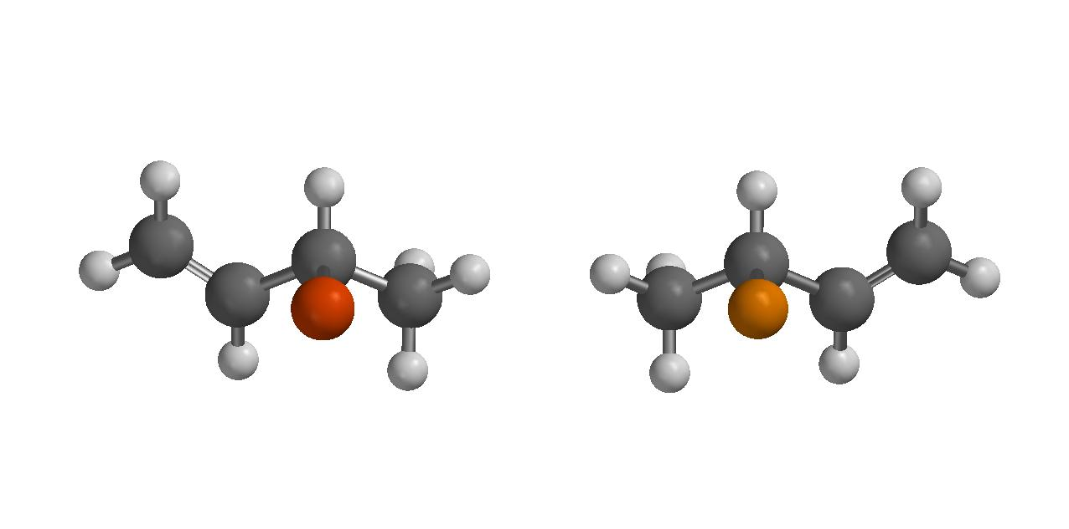
We can see that the two are mirror images, provided we regard Cl in the initial molecule as ”electronically similar” to Br in the final molecule. These two molecules will have “opposite” optical properties, in the sense that if a gas with molecules of the type to the right will rotate the polarization direction of plane polarized light in a certain direction, for example to the right, then a gas with molecules of the type to the left will rotate the polarization direction of the light in the other direction, to the left.
I realize here that it would have been smarter pedagogically to consider an S_{N}2 reaction between ClCH(CH₃)(HC=CH₂) and Cl-. Then, the initial and the final molecule would have had exactly the same formula, but they would still be different molecules; we call them stereoisomers.

5.
a) and b) Localization of minimum nr 1 (without constraining the C-Br distance) yields essentially the same energy and C-Br distance as the ”supposed” minimum geometry at 3.20 Å. Calculation of the vibrational frequencies of this complex reveals only positive eigenvalues of the Hessian matrix (i.e., the matrix of the second derivative of the energy with respect to all the atomic coordinates), which means that we have a true minimum (and not a saddle point):
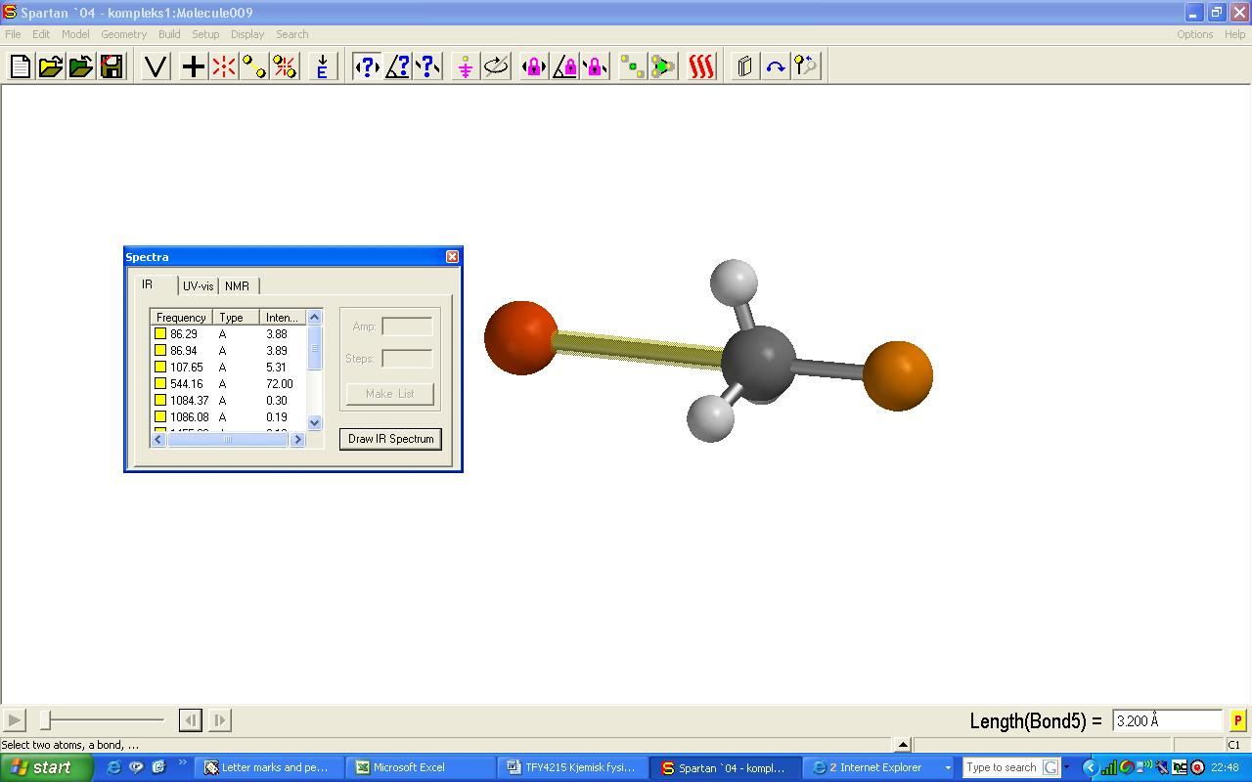

Localization of minimum nr 2 yields the energy -3057.12501 au and C-Br = 1.995 Å, also almost identical to the minimum point found at C-Br = 2.000 Å.

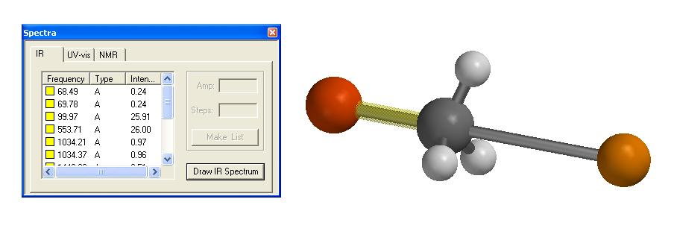
Localization of the transition state yields the energy -3057.10335 au and C-Br = 2.558 Å:

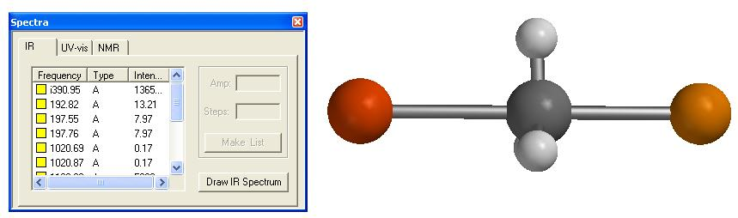

The energy at C-Br = 2.60 Å was slightly lower, -3057.10371 au, a difference of 0.2 kcal/mol. The figure shows that in the TS, the methyl group (CH₃) is essentially planar. In the “Spectra” window, the first frequency (wave number) is given as ”i390.95”. This corresponds to a negative eigenvalue of the Hessian matrix, and since these eigenvalues essentially give us the frequencies squared, a negative eigenvalue can be claimed to represent an imaginary frequency. We only have a single imaginary frequency, so we have indeed localized a transition state for the reaction.
Animation of this imaginary frequency shows that the corresponding movement mainly consists of the carbon atom swinging back and forth along the connection line between Br and Cl. This is essentially proof that we have the correct transition state, i.e., the one that describes the modeled reaction.

6.
The gradient of the energy function becomes

Inserting (x,y) = (-1,0), (1,0) or (0,0) all result in a vanishing gradient. Thus, these three points are all stationary points – either minima, maxima, or so-called saddle points.
The Hessian matrix is

Insertion of (-1,0) gives
i.e., with eigenvalues 8 and 12, both positive. In other words, a minimum!
Insertion of (1,0) also gives
with positive eigenvalues 8 and 12. Also a minimum!
Insertion of (0,0) gives
with eigenvalues -4 and 4. In other words, a first order saddle point!

So: We could imagine that this energy function describes a system that may be in one of two stable configurations, and where this system may go from one stable configuration to the other via a transition state at (0,0). The activation energy will then be

E_{a} = E(0,0) – E(1,0) = 0 – (-1) = 1

and the reaction proceeds along the coordinate x.

