FY1006 Innføring i kvantefysikk og TFY4215 Kjemisk fysikk og kvantemekanikk
Spring 2012 Chemical Physics Exercise 1
To be delivered by Friday 27.04.12

Ethene.

Introduction

Ethylene, C₂H₄, or ethene, according to IUPAC (International Union of Pure and Applied Chemistry), is an important chemical. Ethene is a colorless gas at normal conditions (i.e. atmospheric pressure and room temperature). The molecule has a double bond between the two carbon atoms and belongs to a class of hydrocarbons called alkenes. Alkenes with one double bond has the general formula C_{n}H_{2n} (n=2,3,…). A search on google for ethylene results in millions of hits. On http://en.wikipedia.org/wiki/Ethylene you can find more about the origin of its name, how ethene can be produced, both industrially and in nature, what it can be used for etc. On http://biologi.uio.no/plfys/haa/plfys/hormon/etylen.htm ethene is discussed from a plant physiological point of view.

The ethene molecule is planar (i.e. all the six atoms lie in the same plane) and has a high degree of symmetry:
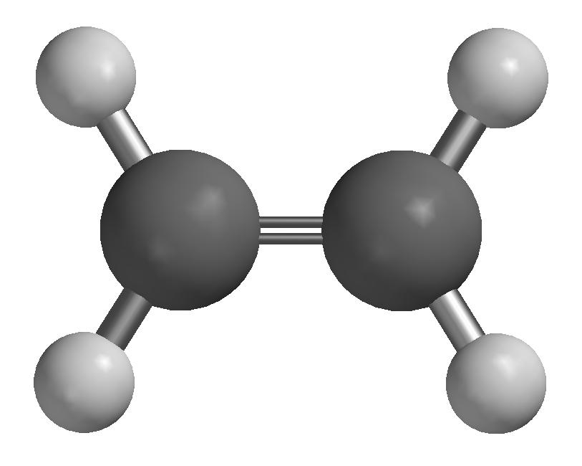

Figure 1. Ethene, C₂H₄

In this exercise, we will do a Hartree-Fock calculation on an ethene molecule and look at some of the calculated wave functions (molecular orbitals, ”MO”) with corresponding energy eigenvalues. The calculated equilibrium geometry can be compared to experimental values. Further, we will calculate the vibrational spectrum of ethene, by finding the eigenvalues of the matrix of second derivatives of the energy with respect to atomic displacements. Calculated vibrational frequencies may also be compared with experiment. We will take a look at which vibrational movements that can be excited by incoming light, i.e. by the oscillating electric field of en electromagnetic wave. We will touch upon naming conventions (nomenclature) and isomerism by replacing two H atoms by Cl atoms. If you want to, you may end the exercise by looking at how ethene molecules may be linked together into long chains, forming so-called polyethene, which is a common plastic material.

Exercises

1. Start SPARTAN by choosing  under Programs.

2. Choose File – New (Ctrl+N). You will get a builder menu on the right side. Choose the Organic builder, and then Alkene from Groups. Click (i.e.: with the left mouse button) on the screen. You now have a molecule consisting of two C atoms with a double bond between and four so-called “open valences”. The molecule may be rotated by holding down the left mouse button. With Shift+right mouse button, the molecule may be scaled up (by pushing the cursor upwards) or down (by pushing the cursor downwards). To the open valences (the yellow sticks) we may connect more atoms if we want to. By going back to the “View” mode (by clicking the V on the symbol menu above the green “working area”), all open valences are automatically replaced by H atoms. And this is exactly what we need in this case, to make ethene, C₂H₄.

3. Choose File – Save As, make a new folder, call it (e.g.) ETHENE, and store the molecule with filename (e.g.) c2h4 and filetype spartan (which is the default type). All the results of the calculations on this molecule will now end up in the file c2h4.spartan. The content of this file may be read in SPARTAN with Display – Output when a calculation has finished.

4. Next, we will set up a Hartree-Fock calculation that does the following:

- Optimize the geometry of ethene
- Calculate the vibrational frequencies
- Print out all the MO coefficients, both for MOs that are occupied by electrons and for those MOs that are empty
- Generate surfaces with constant value for selected MOs
- Generate a surface with constant value of the electron density, and on this surface, display how the electrostatic potential varies in space by using a color code where red denotes most negative and blue denotes most positive

Choose Setup – Calculations. This brings up “Calculate Equilibrium Geometry with Hartree-Fock/3-21G” as the suggested calculation, and that is exactly what we will use. The notation 3-21G denotes the choice of basis functions for the various atoms, to be specific, two s-functions for each H atom and three s- and six p-functions for each C atom. We may think of these functions as the 1s and 2s states in H and 1s, 2s, 2p_{x}, 2p_{y}, 2p_{z}, 3s, 3p_{x}, 3p_{y} and 3p_{z} states in C, although this is only approximately correct, since the basis functions that the program uses are so-called Gaussian orbitals () and not “real” atomic orbitals (, at least for the H atom!). Check out Compute – IR and Print – Orbitals and press OK. The Total Charge – Neutral and Multiplicity – Singlet are both OK. (Comment: All the systems that we will study in these three exercises have ground states with en even number 2N of electrons, occupying the N molecular orbitals with the lowest energy. Hence, the electrons always come in pairs in the spatial orbitals, one with spin “up” and one with spin “down”, with the consequence that the total spin of the electrons is S=0, i.e., a singlet.) In choosing Compute – IR, we instructed the program to calculate the vibrational frequencies of the molecule. The choice Print – Orbitals results in all MO coefficients being printed to the file c2h4.spartan.

Visualization of MOs can (e.g.) be done by generating surfaces with constant value of the given orbital. We instruct SPARTAN to generate such surfaces by choosing Setup – Surfaces. Click on Add and choose Surface – HOMO and Isovalue – 0.032 and click OK. HOMO means Highest Occupied Molecular Orbital, i.e. the MO that is occupied by electrons and that has the highest energy. Next, choose Surface – LUMO with the same value. LUMO means Lowest Unoccupied Molecular Orbital, i.e. the MO that is unoccupied by electrons and has the lowest energy. Often, we are particularly interested in these two MOs. According to the so-called Frontier Orbital Theory, chemical reactions between two molecules will typically take place in such a way that electrons in the HOMO of one molecule “enter” the (empty) LUMO of the other molecule. A more correct statement would be: In the reaction product that is formed between two molecules A and B, we will have new MOs that can be expressed as linear combinations of the MOs of the two original molecules, e.g.

and

The two electrons that prior to the reactions occupied the HOMO in molecule A had a total energy of 2E_{A}. If the LUMO of molecule B corresponds to an energy E_{B} which is not too different from E_{A,} the new orbitals and in the reaction product will typically correspond to states with energy E₁ < E_{A} and E₂ > E_{A}, respectively. Hence, the two electrons will both occupy the orbital in the reaction product, and thereby have a total energy 2E₁ < 2E_{A}. In other words: The reaction results in a product with lower energy than the two separate reactants, which is energetically favourable! The figure below illustrates how this happens. Here, it is implicitly assumed that these particular electrons are the ones “taking active part” in the chemical reaction, and therefore provide the main contribution to changes in orbitals and corresponding energies.

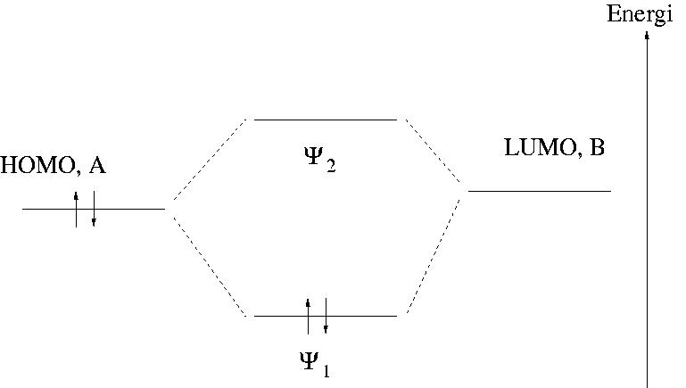

Figure 2. Illustration of ”Frontier Orbital Theory”. See the main text for an explanation.

In Ingjald’s “Ekstraøving 1”, the focus was on MOs in ethene. Let us therefore also generate some of the other “equi-orbital-surfaces”, for example HOMO-5 (i.e., MO nr 5 below HOMO), HOMO-6 and HOMO-7. For these three MOs, it is better to choose isovalues 0.10, 0.016 and 0.016 instead of 0.032.
Finally, we make a surface with constant electron density 0.08 (Surface – density(bond)). In the box Property, we choose potential. This will give us an idea of how the value of the electrostatic potential varies in different regions of the molecule. We have now specified a total of six surfaces and may close the Surfaces window.

5. Start the calculation with Setup – Submit. The job will finish in seconds. Click OK in the windows that tell you that the job has started or is finished.

6. Equilibrium geometry:
A Hartree-Fock calculation like this is based on various approximations, so we have no reason to expect the calculated geometry to be exactly equal to what is found in experiment. Measure the C-H and the C=C bond lengths and the HCH and HCC bond angles and compare with the following experimental values: C-H = 1.076Å, C=C = 1.33Å, HCH = 116.6º, HCC = 121.7º. Determine a mean deviation for these four geometry parameters (a_{i}):

7. Open the file c2h4.spartan with Display – Output.
a) Calculate the number of basis functions that contribute to each MO and check that your answer is consistent with what is printed as ”Number of basis functions”. Also, calculate the total number of electrons and compare with ”Number of electrons” in the output file.
b) How many iterations (cycles) did the program use to optimize the geometry? Optional: Close the output file, click ”<?>” in the menu, then click the C=C double bond and change this distance to, for example, 1.815 Å before you save the molecule and run the computation again. You have now used an initial geometry which is worse than in the first calculation, and this results in a larger value of the gradient of the energy () initially (”Max Grad” in Cycle 1) and also more iterations in the geometry optimization before the equilibrium geometry has been reached. You may also consider constructing even worse starting geometries by changing bond lengths, bond angles and torsional angles before running the geometry optimization once more. Do this and check in the output file to find out how many iterations that were required to find the equilibrium geometry.
c) The program has analytical expressions for the gradient of the energy () but calculates all the second derivatives of the energy (i.e. the Hessian matrix H) numerically by calculating in the 36 geometries that are obtained by moving one by one of the 6 atoms a little bit in the positive and negative x, y and z direction, relative to the calculated equilibrium geometry. (”Estimating Force Constant Matrix by central-differences”, cf øving 10) At this stage, the vibrational spectrum is calculated. How long CPU time did the program use to optimize the geometry and calculate the vibrational spectrum? (”HF Program CPU Time”)
d) Under ”PC SPARTAN STUDENT Properties Program” the cartesian coordinates of the atoms are given, as well as the energy and MO coefficients of all the MOs. In which plane is the molecule located? Along which axis is the C=C double bond?
e) How many MOs are occupied by electrons? (Remember the Pauli principle!) Which MOs correspond to HOMO, LUMO and the remaining three for which we generated equi-orbital surfaces (i.e. HOMO-5, HOMO-6, HOMO-7)?
f) Minimize the output window and choose Display – Surface. Check the box next to HOMO. You probably recognize the π-orbital from Ekstraøving 1? (Blue: positive. Red: negative.) Using what you found in d), which atomic p-orbitals contribute to this π-orbital? (I.e.: p_{x}, p_{y} or p_{z}?) Check that your answer is consistent with the MO coefficients in the output file.
g) Inspect the other orbitals in the same way and try to find out which atomic orbitals that (mainly) contribute to the various MOs. Can one of these MOs be claimed to represent the so-called σ-orbital (cf Ekstraøving 1)? Compare the two orbitals HOMO and LUMO (visually). Based on their appearance, do you find it reasonable that LUMO has a higher energy than HOMO? Do the corresponding comparison between the two orbitals HOMO-7 and HOMO-6.
h) You will notice in the output file that each MO has been assigned a certain symmetry, e.g., Ag, B1u etc. Here, g denotes “gerade” and u denotes “ungerade”, which is German for “even” and “odd”, respectively (i.e.: parity). Inspect a couple of MOs (with Display – Surface) and check that the parity is consistent with the symmetry assignment in the output file (g or u). (Even parity means that the wave function has the same value in r and –r, whereas odd parity means that the wave function has opposite value in r and –r.)
i) Inspect the surface with constant electron density and the color coded electrostatic potential. Red areas represent low potential, in other words, areas that will be attracted by “electrophile” (“electron loving”) areas in a potential “reaction partner”. Is the location of red areas where you would expect to find a surplus of negative charge in the ethene molecule?
j) The ethene molecule has a symmetry that makes it belong to the so called point group D_{2h}. Here, D_{n} means that the molecule has an n-fold rotation axis and n 2-fold rotation axes perpendicular to the n-fold axis. (In ethene: Three mutually perpendicular 2-fold rotation axes.) The subscript h implies a horizontal mirror plane, where ”horizontal” means that the mirror plane is perpendicular to the n-fold rotation axis.
For a molecule like ethene, i.e., with 6 atoms and with D_{2h} symmetry, how many, and which coordinates must be specified in order to determine the complete molecular geometry? Are several coordinate choices possible? (With “molecular geometry”, we mean the “internal structure” of the molecule, not whether the molecule is in Trondheim or Bergen, or whether the C=C axis points in this or that direction.) Which bond lengths and/or bond angles measured in point 6 above are not independent coordinates?

8. Vibrational frequencies:
Choosing Display – Spectra you get a window with the calculated vibrational frequencies for ethene. Clicking “Draw IR Spectrum”, you get a plot of the calculated absorption spectrum for wave numbers k in the region between 4000 and 500 cm⁻¹.
a) Calculate the corresponding region for wavelength, frequency and energy of the absorbed light. Where is this region, in comparison with visible light?
b) In experiments, one finds that a gas of ethene absorbs strongest at the “frequency” (actually: wave number) 949 cm⁻¹. How does this compare with the “strongest band” in our Hartree-Fock calculation? (Comment: It is well known among quantum chemists that vibrational frequencies calculated with Hartree-Fock methods need to be scaled by a factor of the order of 0.9 to fit with experimental values.)
c) Study the vibrational motion of the frequency 1116 cm⁻¹ by clicking the little yellow box. Illustrate the vibrational motion by drawing arrows on the atoms, when viewing the molecule “from the side”:

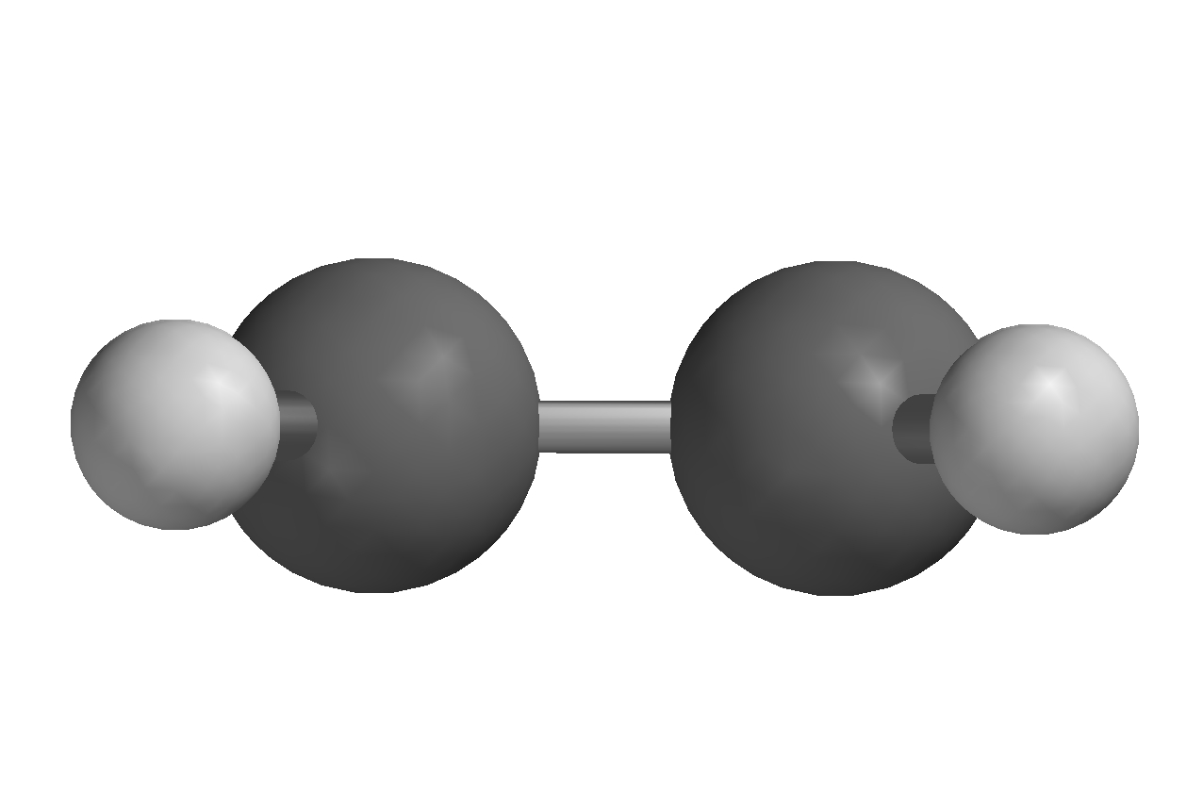

Figure 3. Ethene viewed ”from the side”.

If you think in classical terms and imagine each of the atoms as a point charge, positive for H and negative for C, does it make sense that this particular frequency is so-called IR active? An IR active frequency is such that the vibrational motion corresponds to an oscillating electric dipole. Check also the frequency 1522 cm⁻¹ which is IR inactive.

9. Isomerism in dichloro ethene

How many different isomers exist for dichloro ethene, C₂H₂Cl₂? Build them in Spartan. Give the different isomers correct names. Optimize the geometry of each of them with the Hartree-Fock method and the basis set 3-21G (i.e., on the ”HF/3-21G level”). What is the relative stability (i.e., the relative energies) of the different isomers on the HF/3-21G level? Is the result as expected in terms of classical thinking, where you regard the atoms as point charges?

10. Polyethene (Optional)

Polyethene is a kind of plastic where the molecules consist of many ethene molecules ”linked” together into long chains.

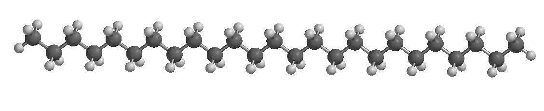

Figure 4. Polyethene.

Figure 4 shows an example, C₂₅H₅₂, which we can imagine being made, starting with methane, CH₄, and then ”insert” an ethene molecule between C and one of the H atoms (Figure 5),

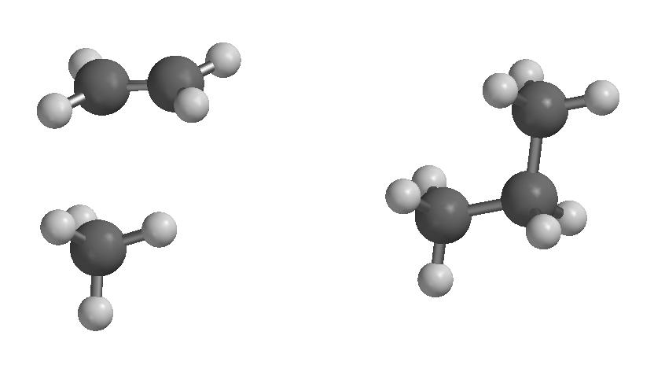

→

Figure 5. Insertion of ethene between C and H in methane.

in such a way that one of the original C-H bonds in methane is broken, the original C=C double bond in ethene is converted into a C-C single bond, and a new C-C and C-H single bond is formed. And in this manner we may continue with 11 more ethene molecules until we have a chain of 25 C atoms. And so on! In reality, such polyethene molecules may contain several tens of thousands of C atoms chained together in this manner.
One question one could ask in this connection: Is this linking together of ethene molecules favourable, i.e., from en energy point of view? To answer this question, we may model a single step in the polymerization process, i.e.

C_{n}H_{2n+2} + C₂H₄ → C_{n+2}H_{2n+6}

with a ”not too big” value of n, for example n=5.
Thus: Build pentane, C₅H₁₂, and heptane, C₇H₁₆, optimize their geometries with Hartree-Fock calculations, and determine the polymerization energy

E_{pol} = E(heptan) – E(pentan) – E(eten)

Compare with the experimental value of about -25 kcal/mol. The conclusion must be that the electrons are “better off” when the ethene molecules are linked together in a long chain than when they wander around on their own. Alternative formulation: Four electrons obtain a lower total energy in two C-C single bonds than when they “lump” together in a C=C double bond. Perhaps not so unreasonable?

Given information:
1 au = 627.5 kcal/mol = 27.21 eV

